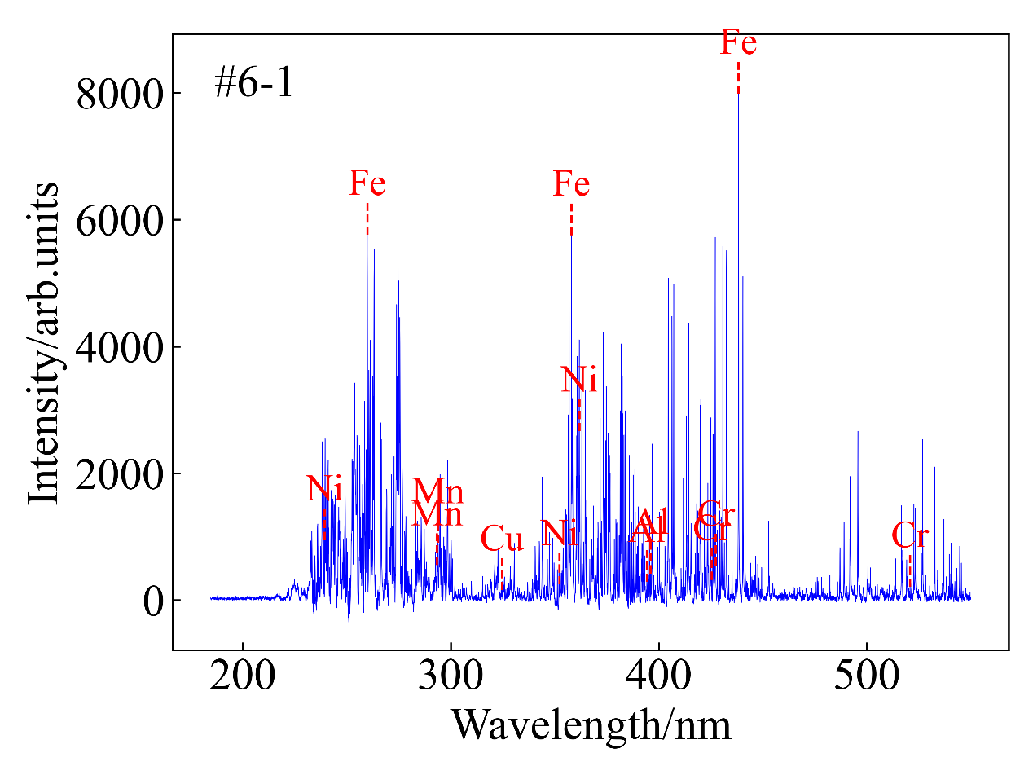

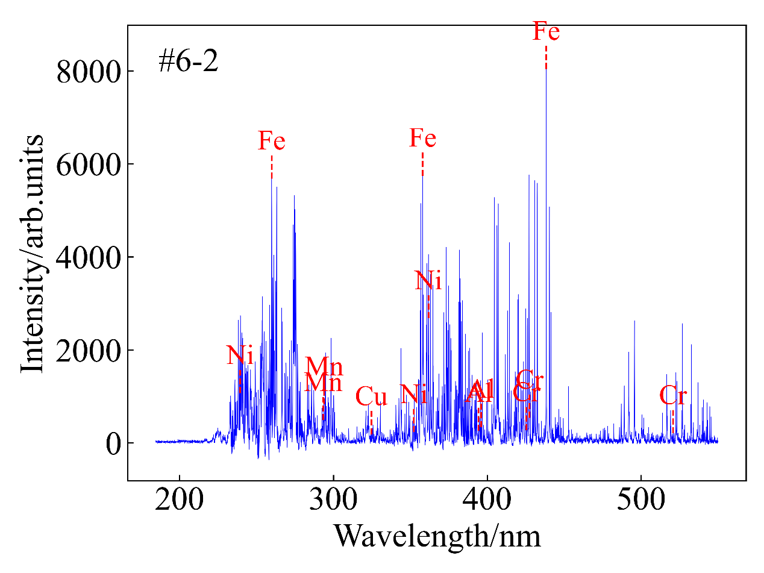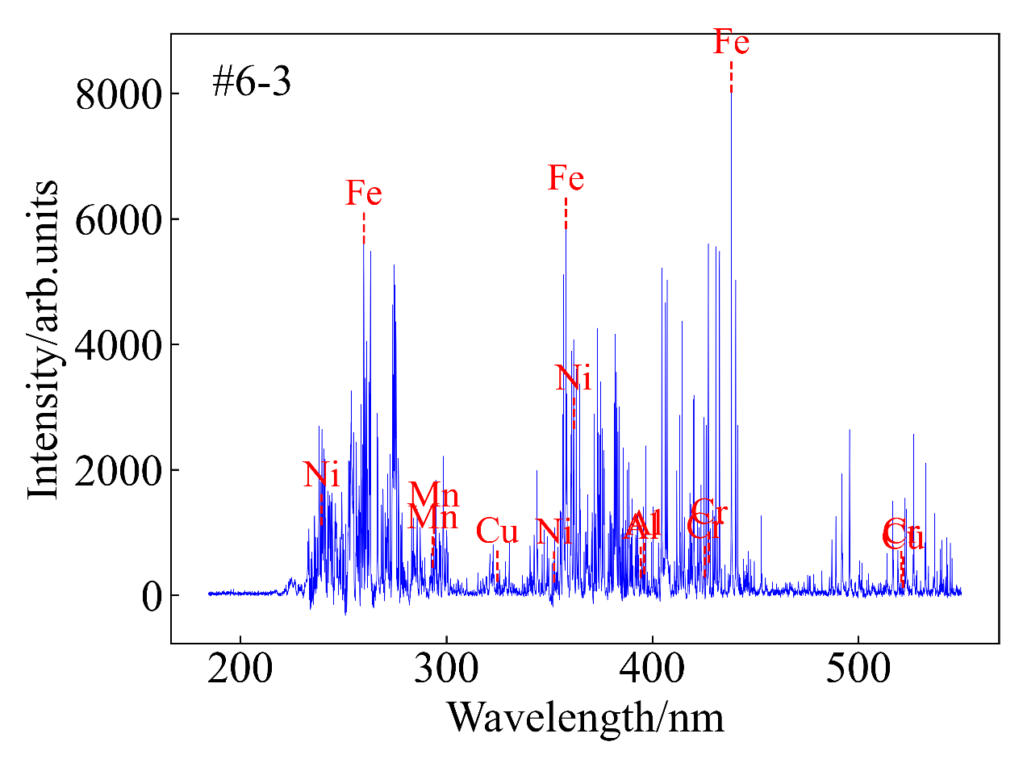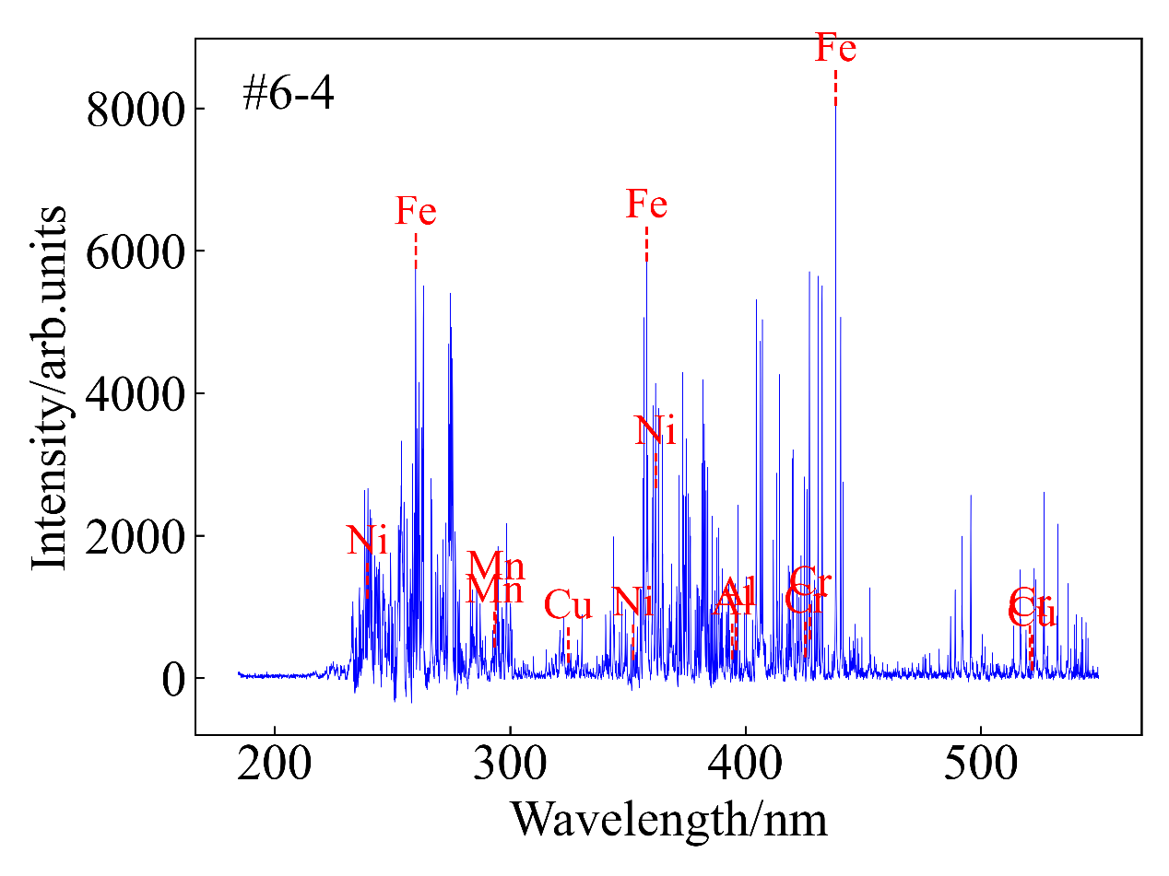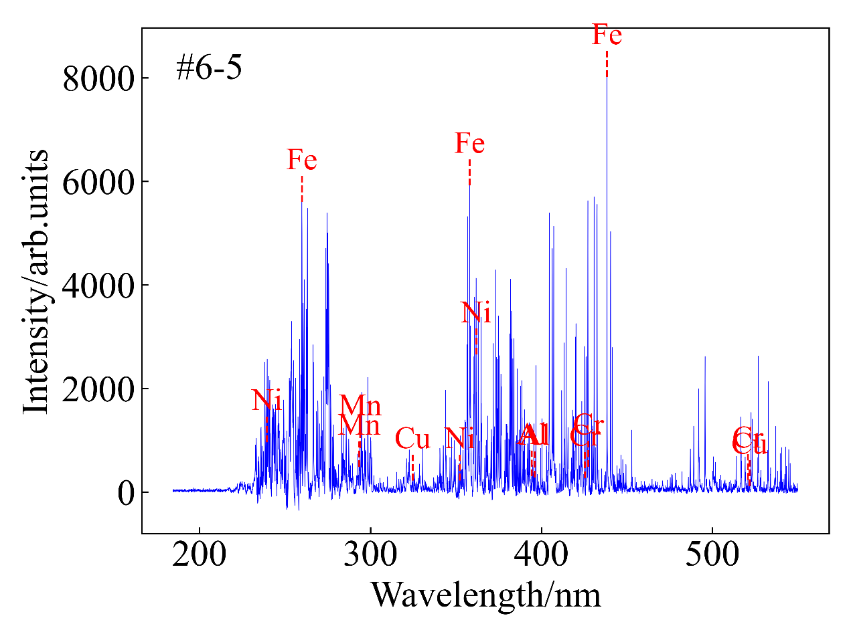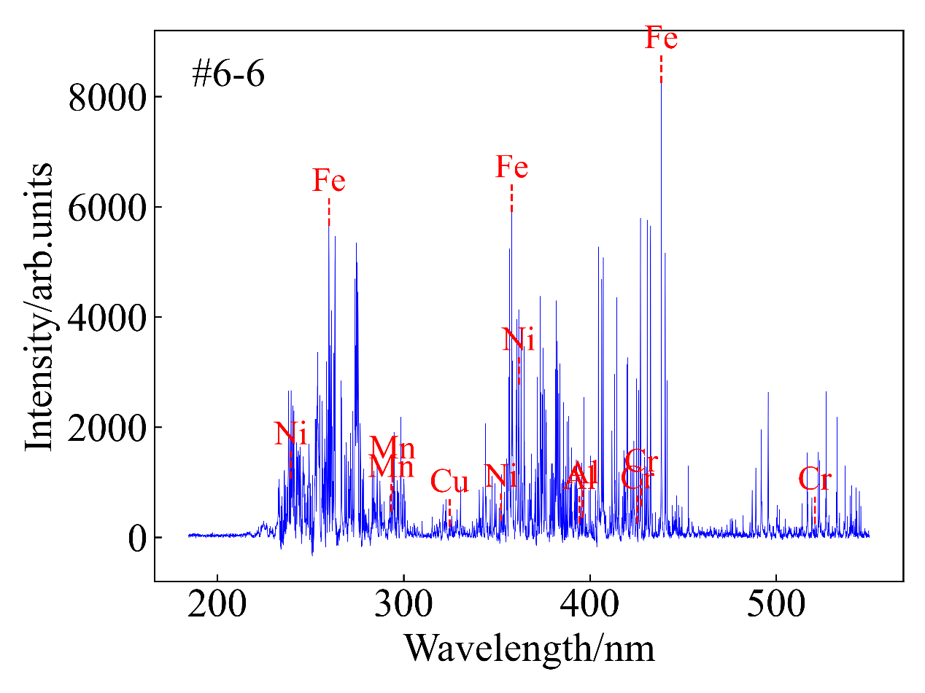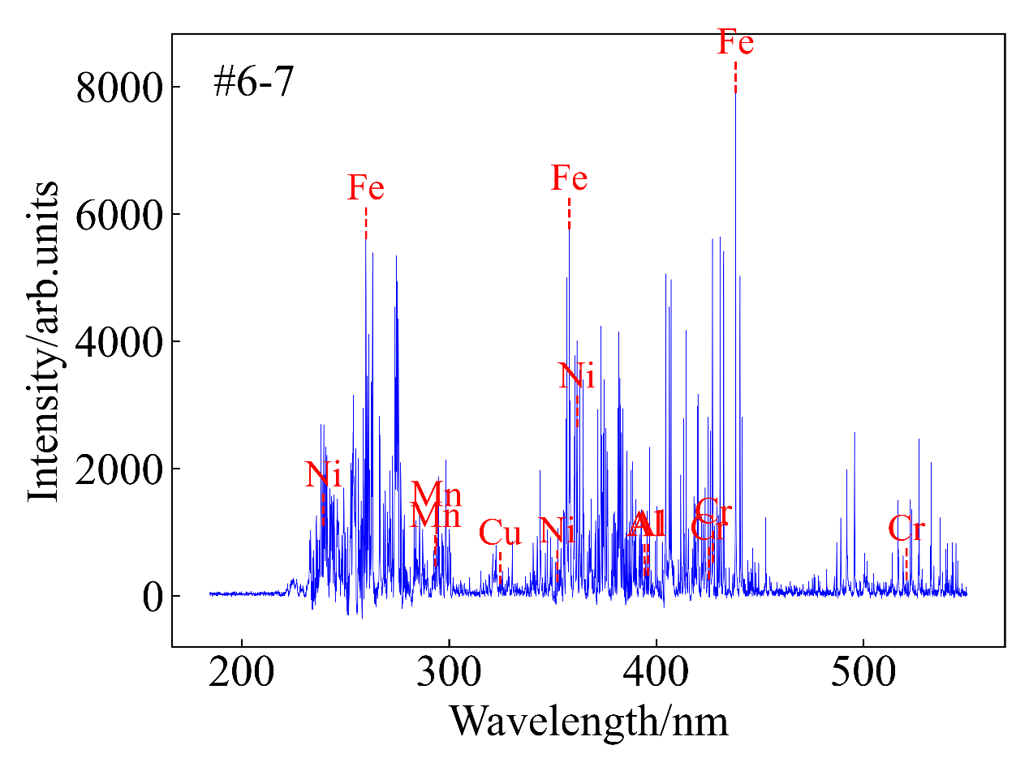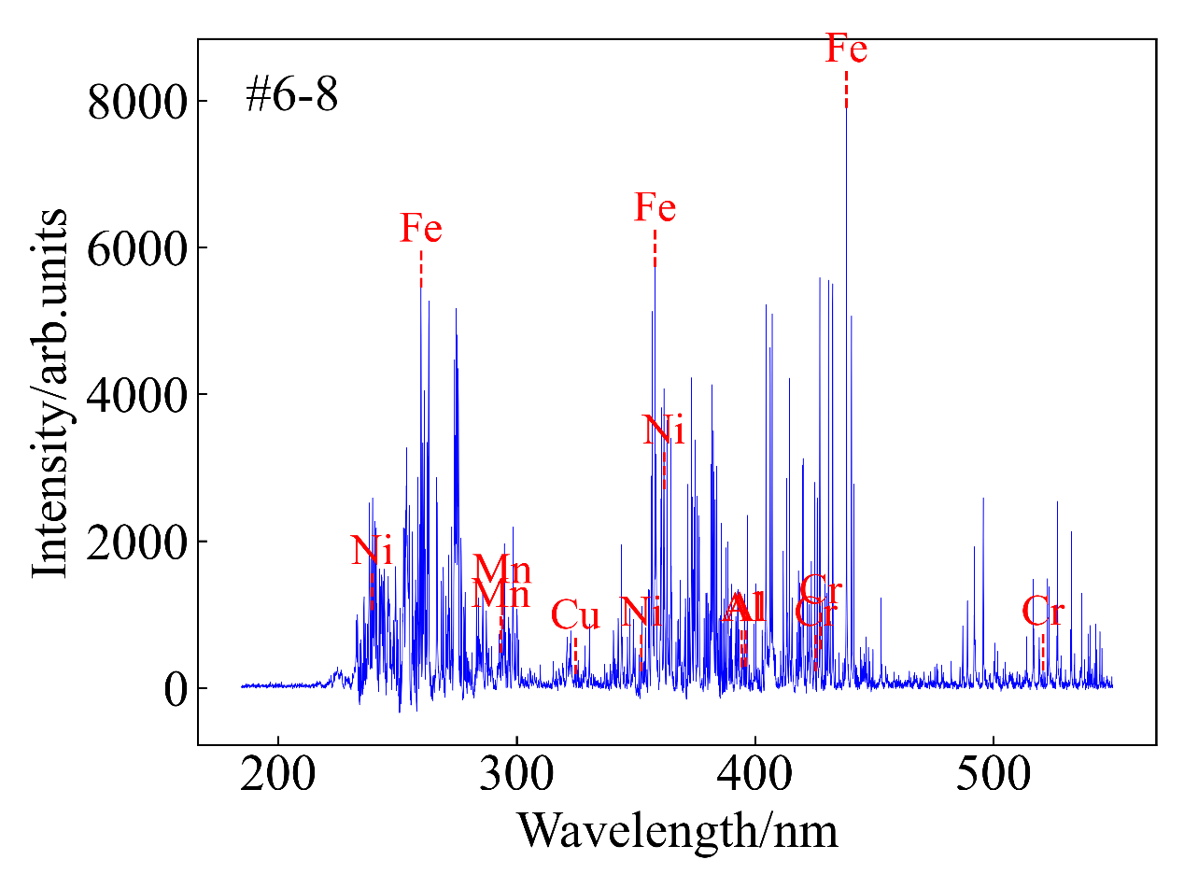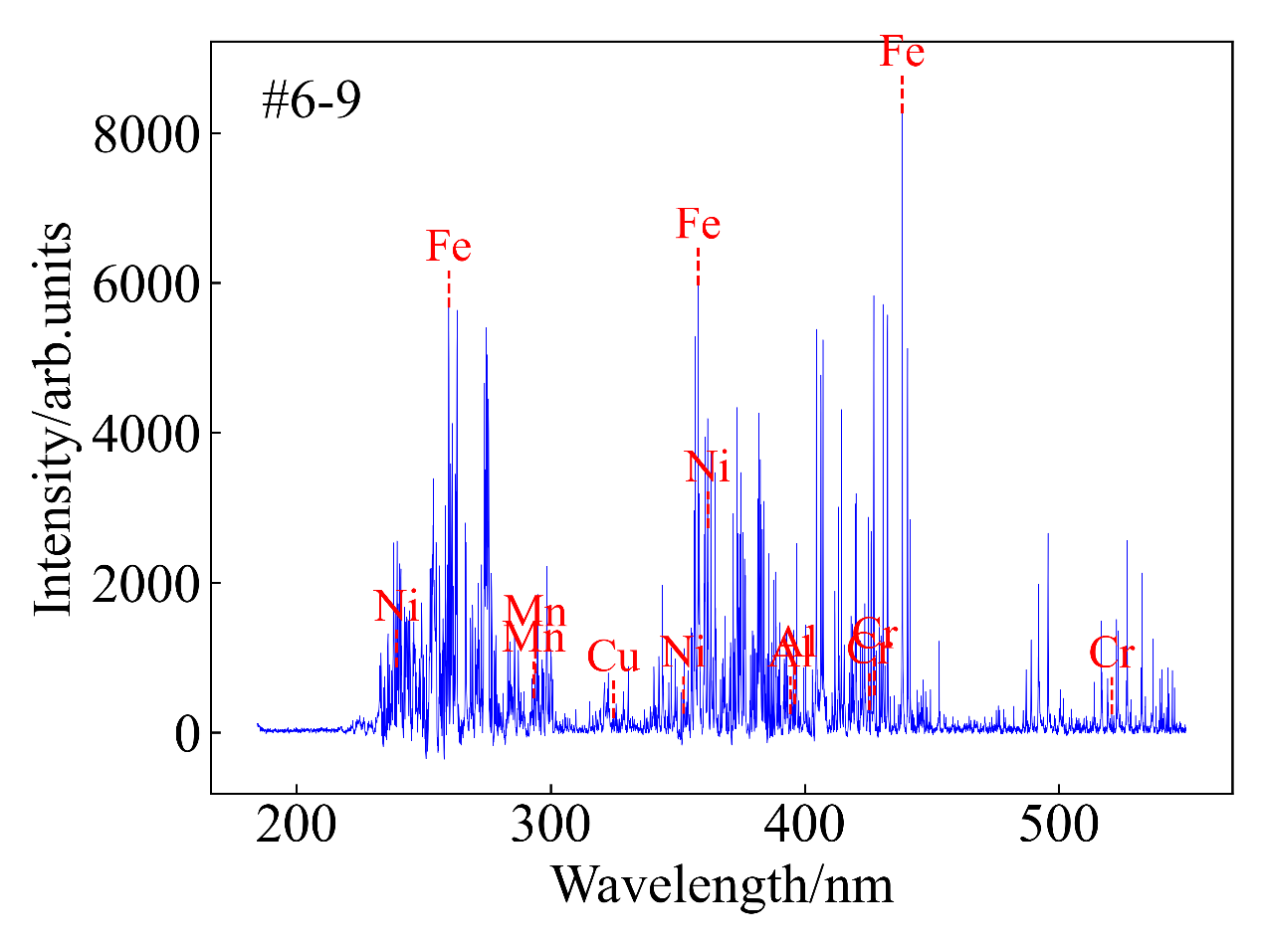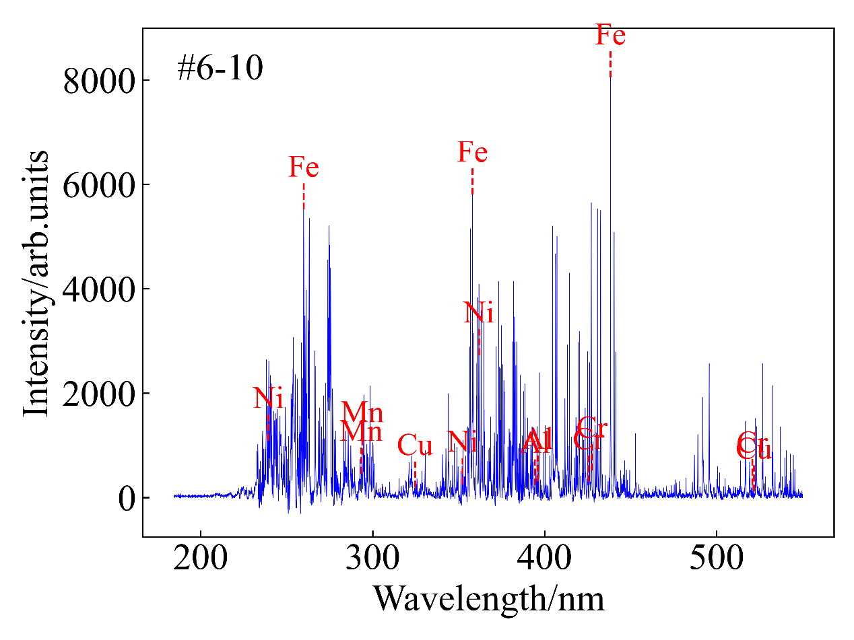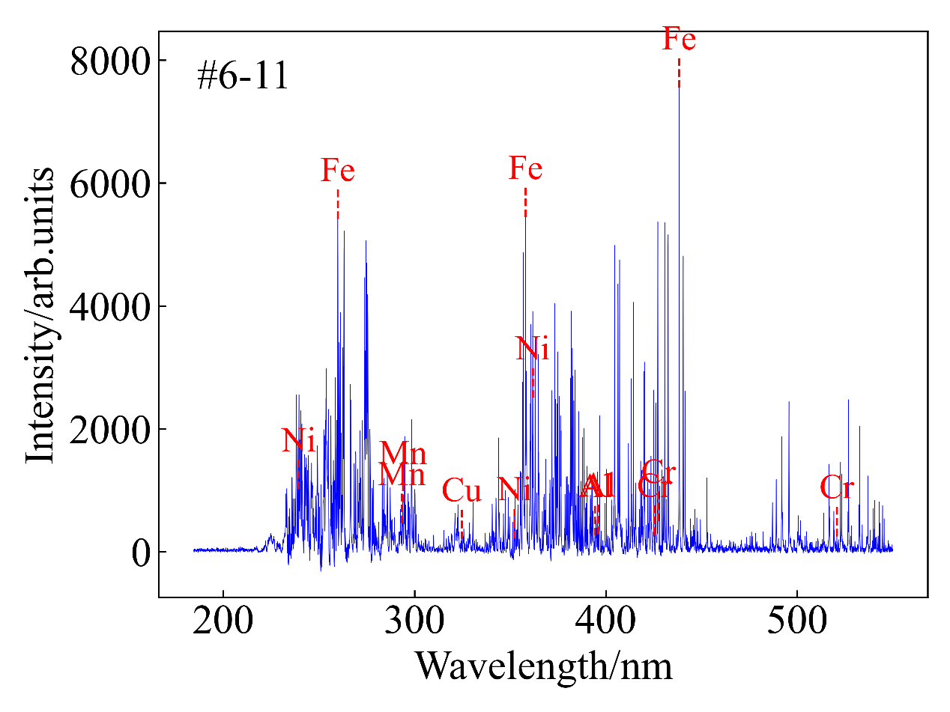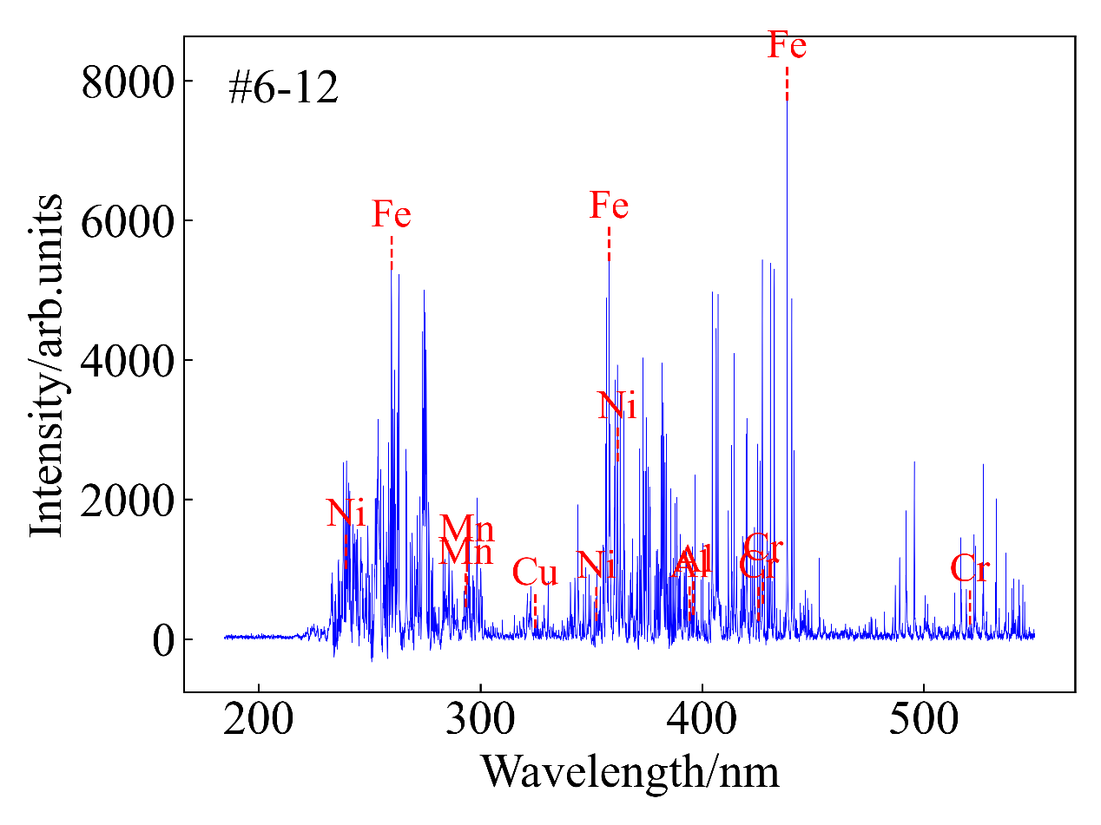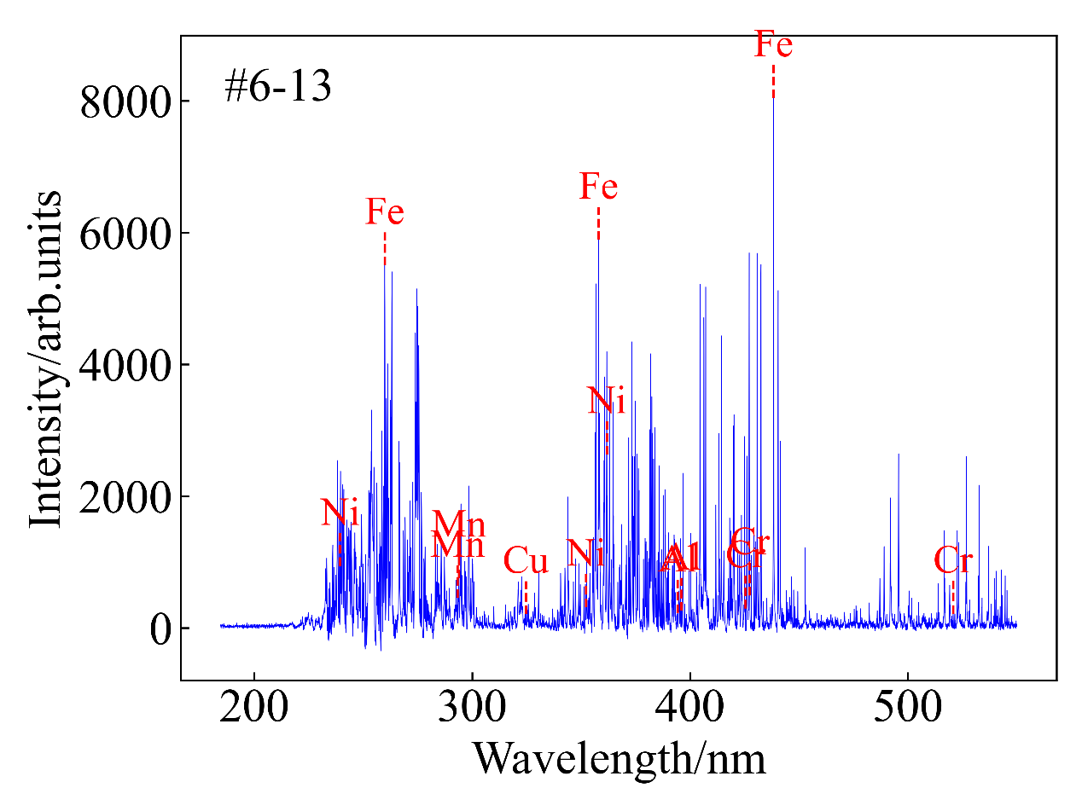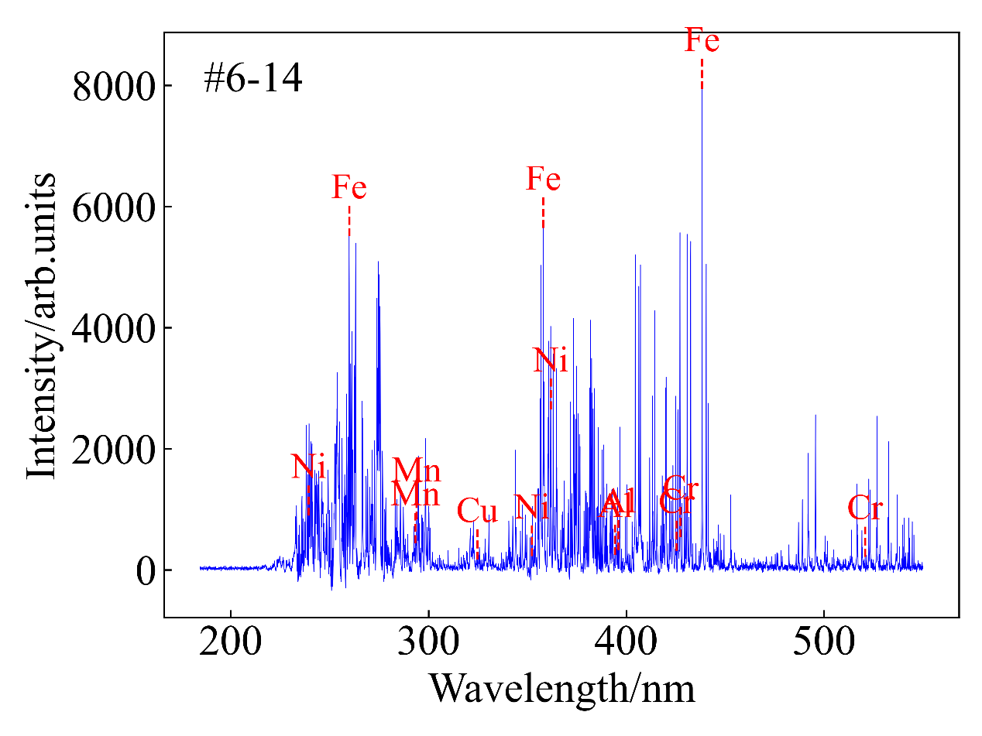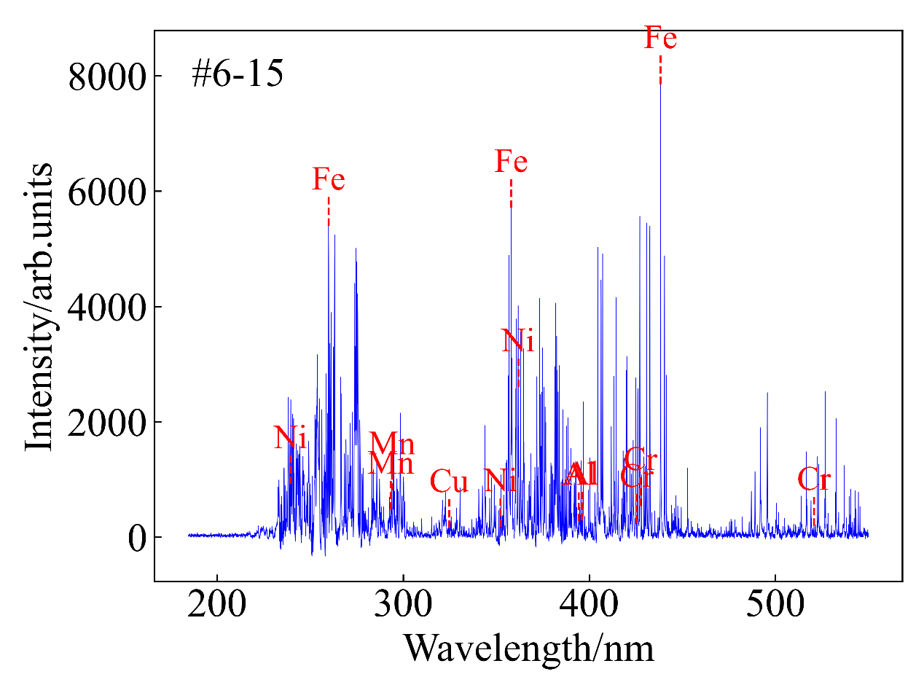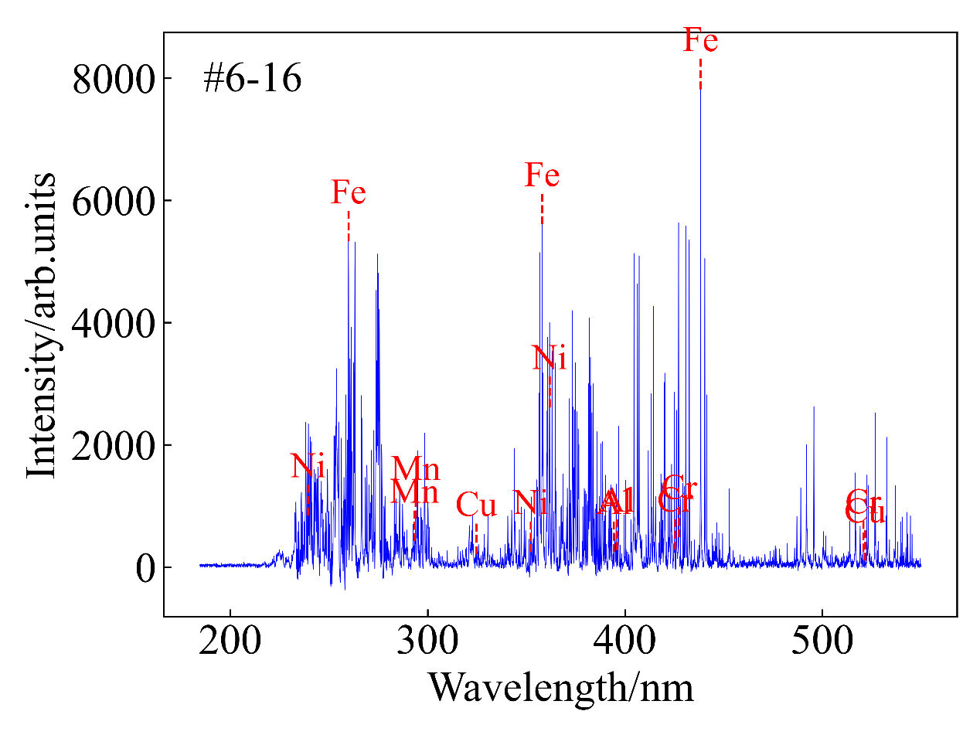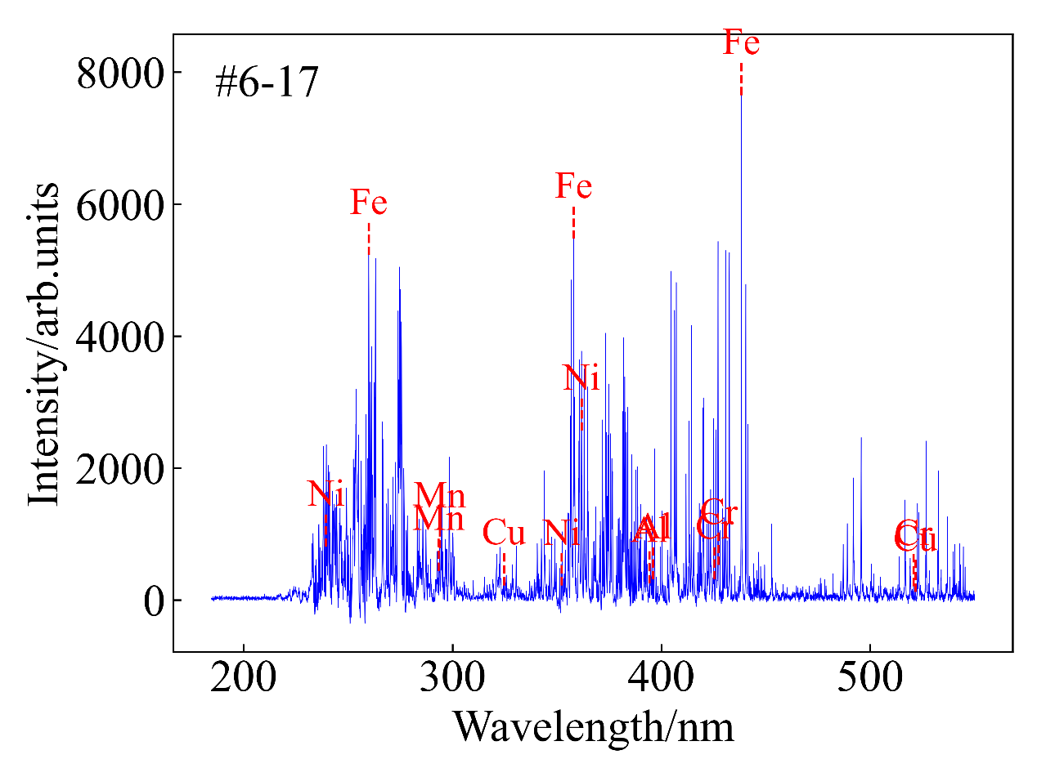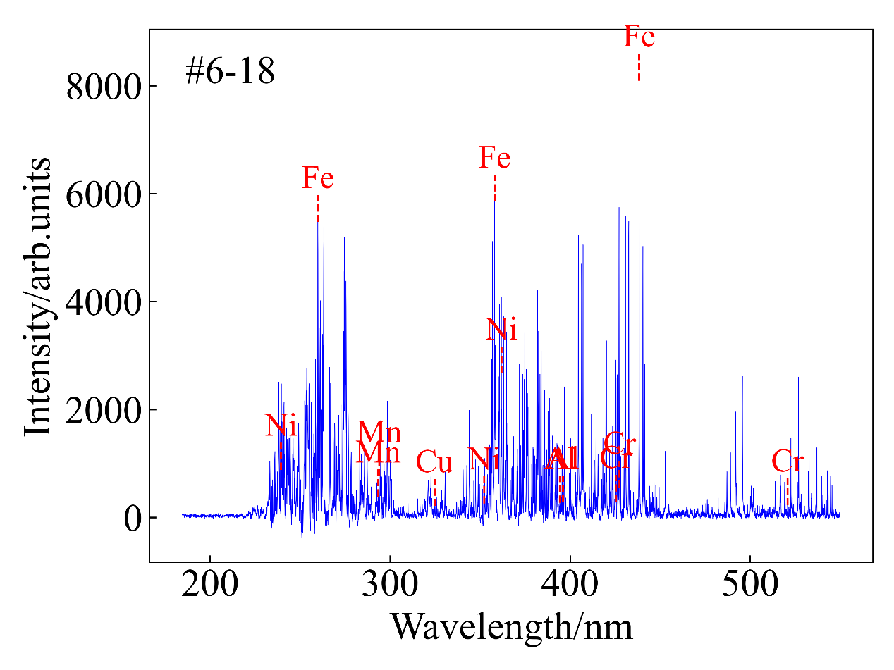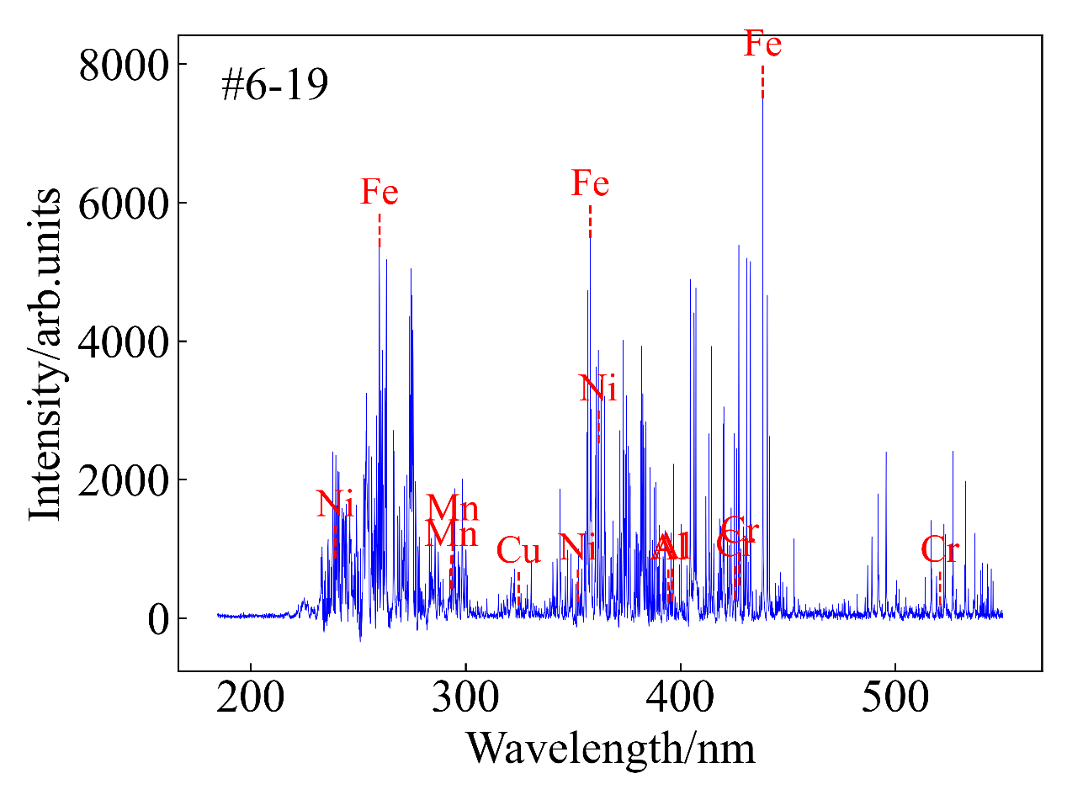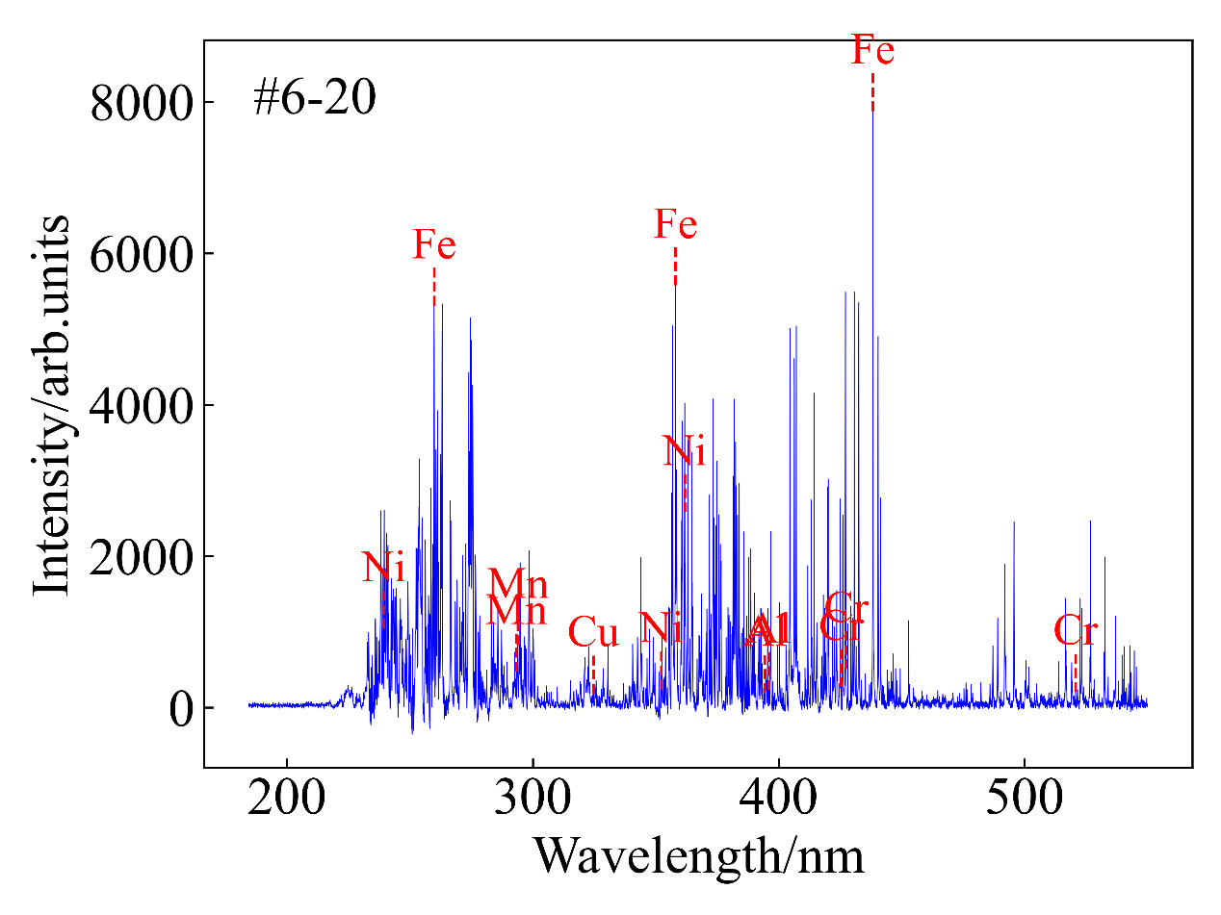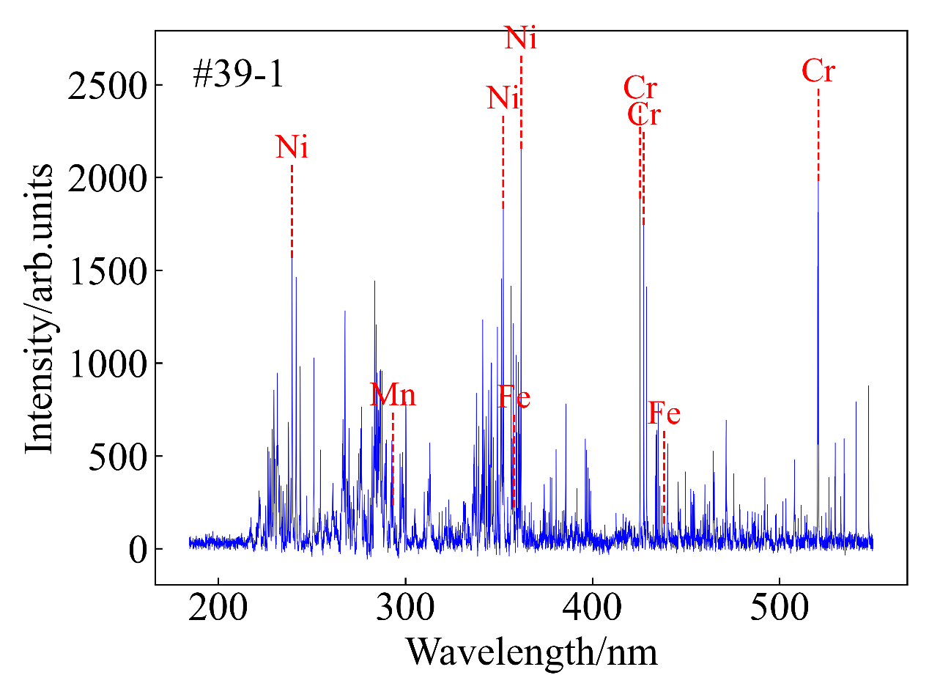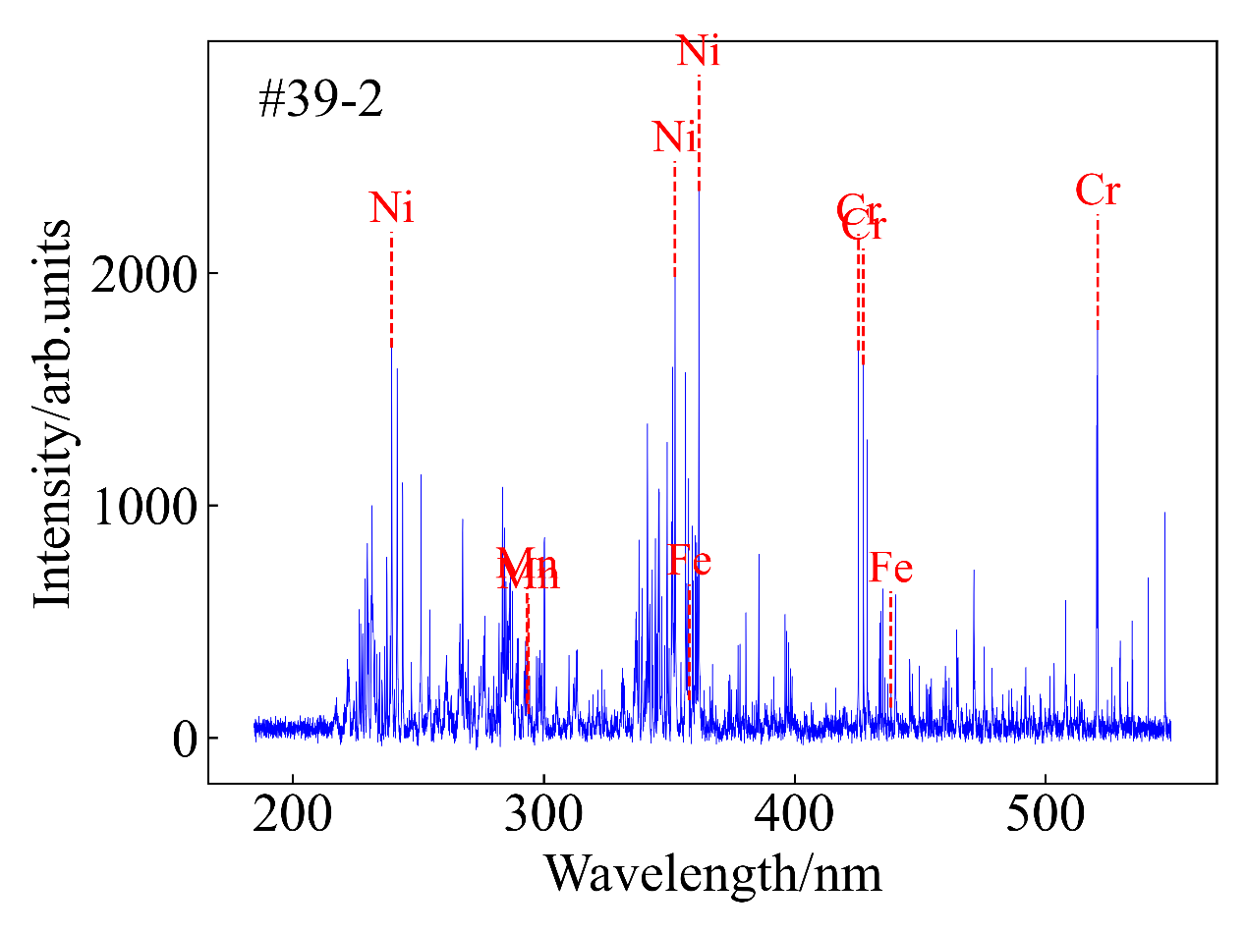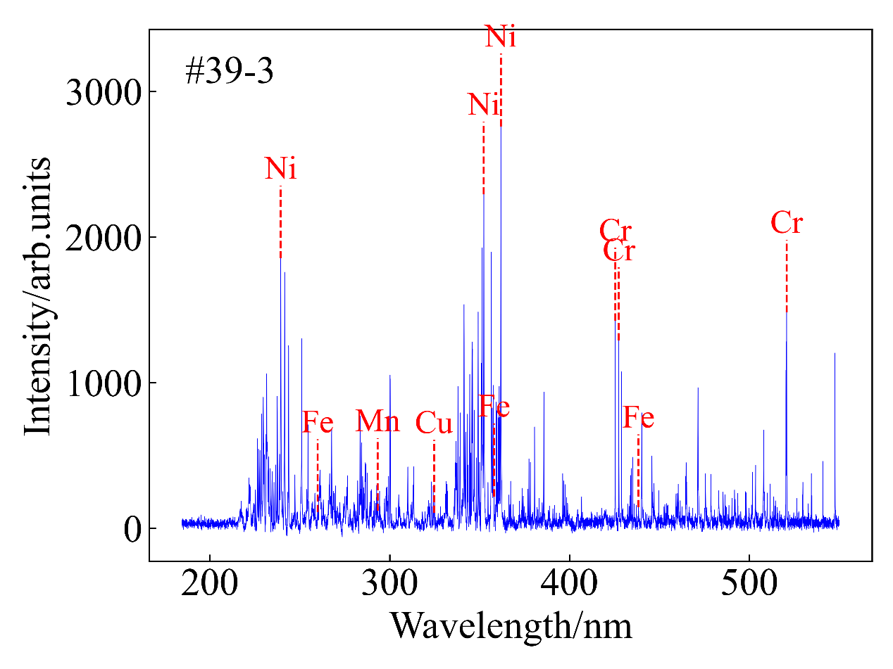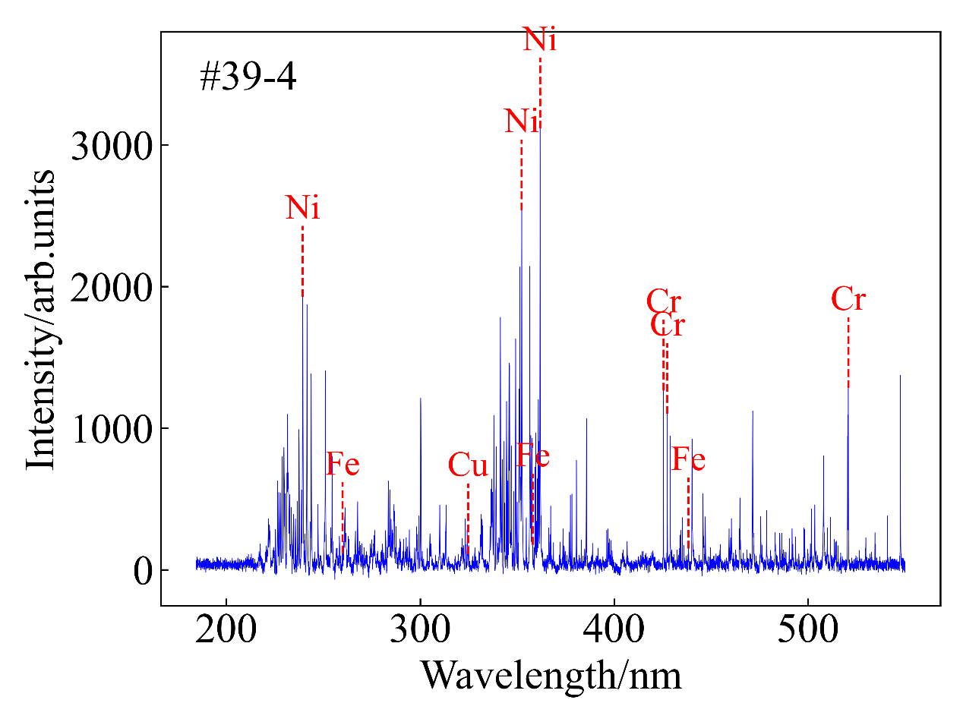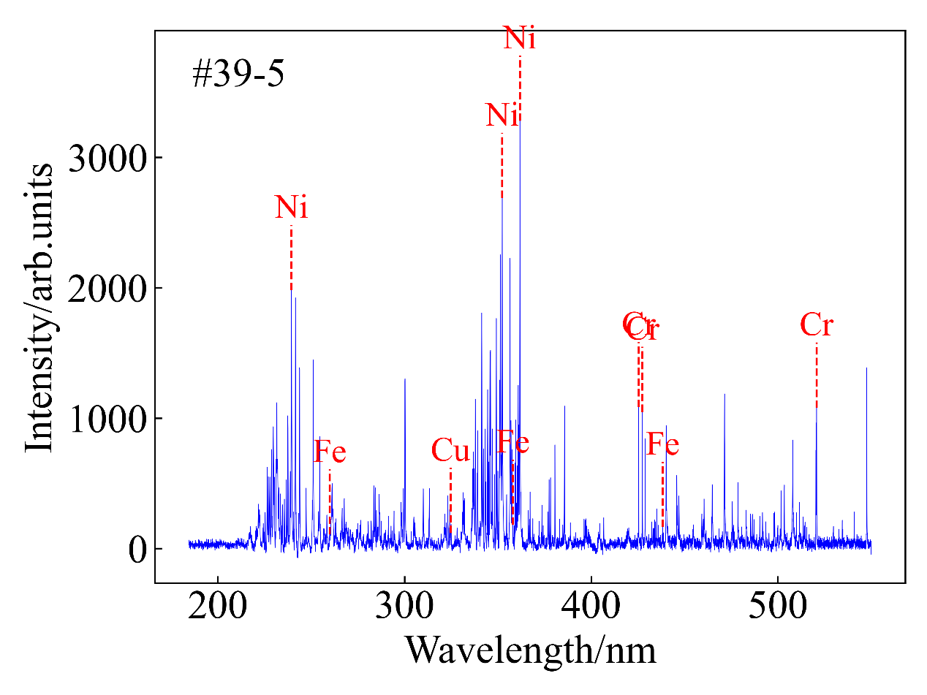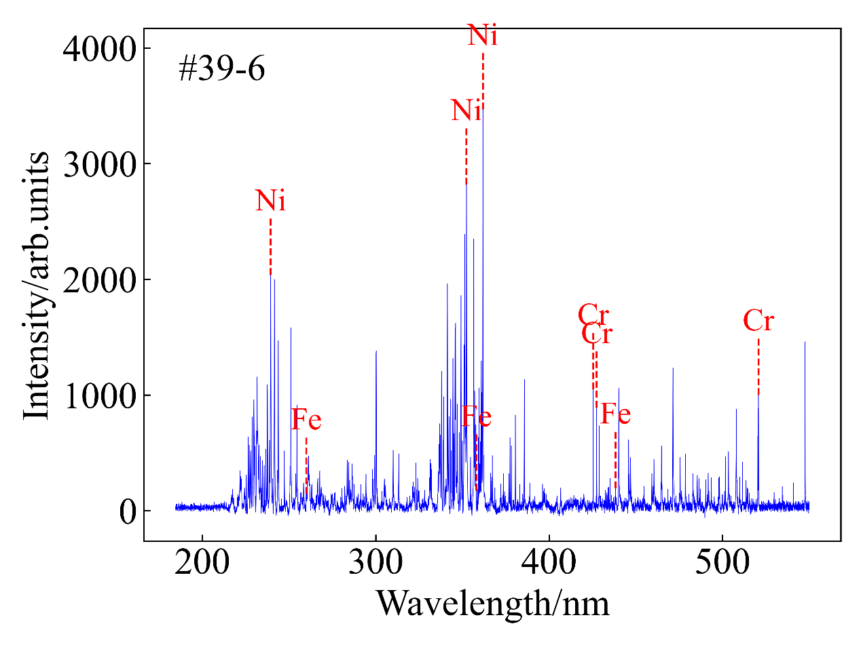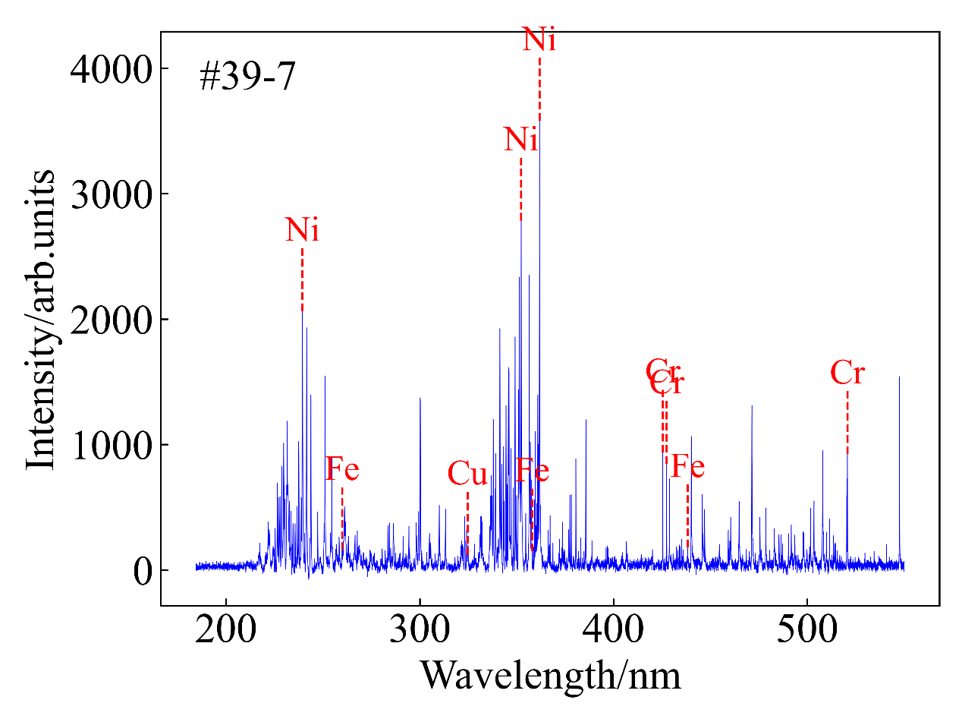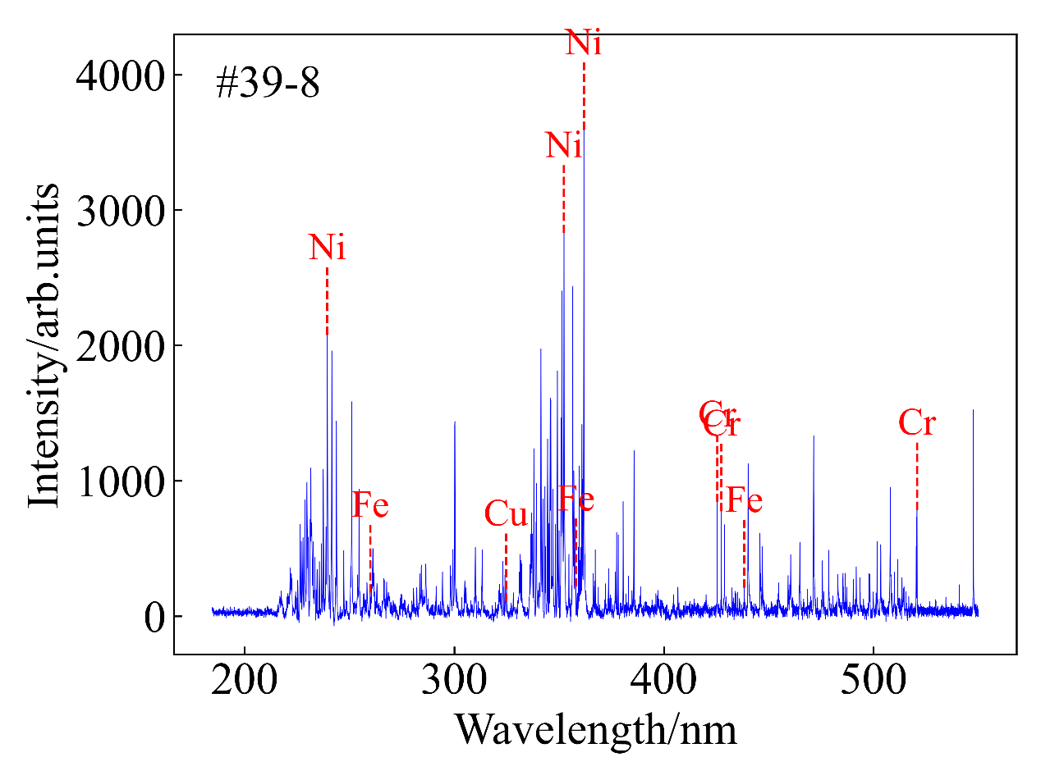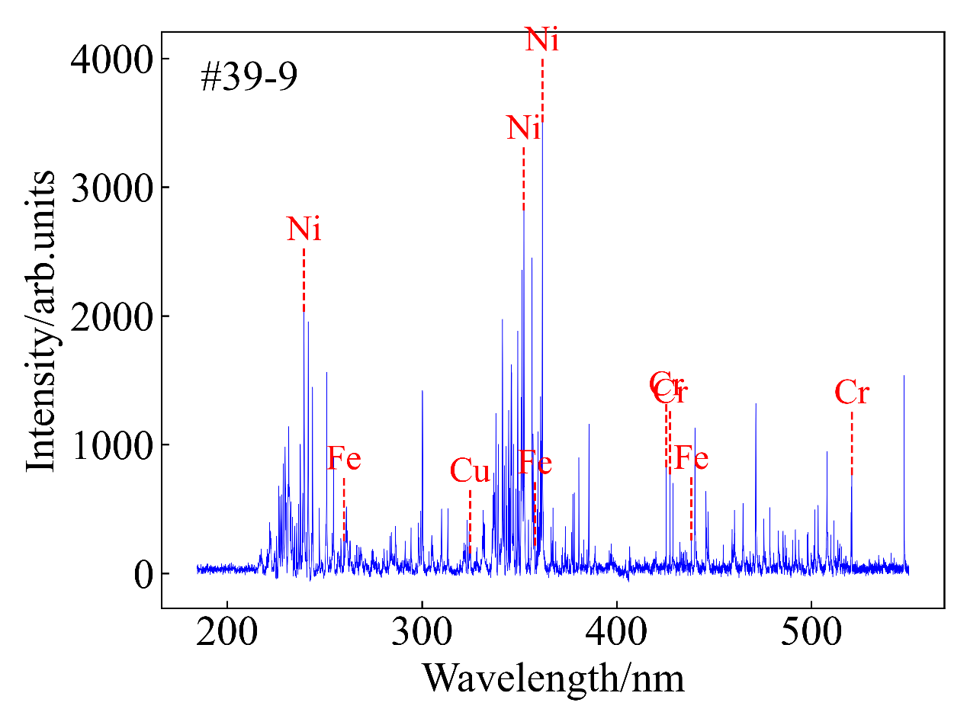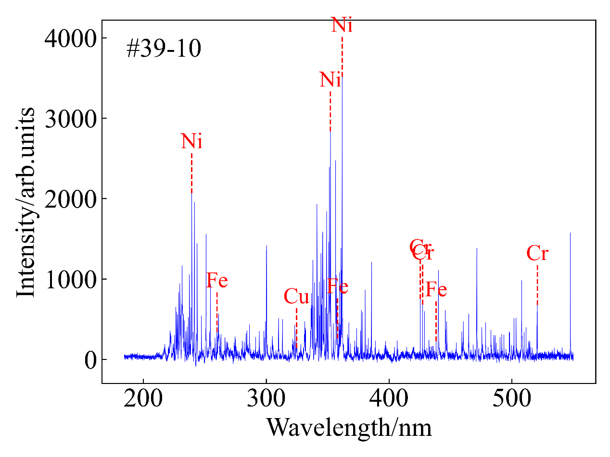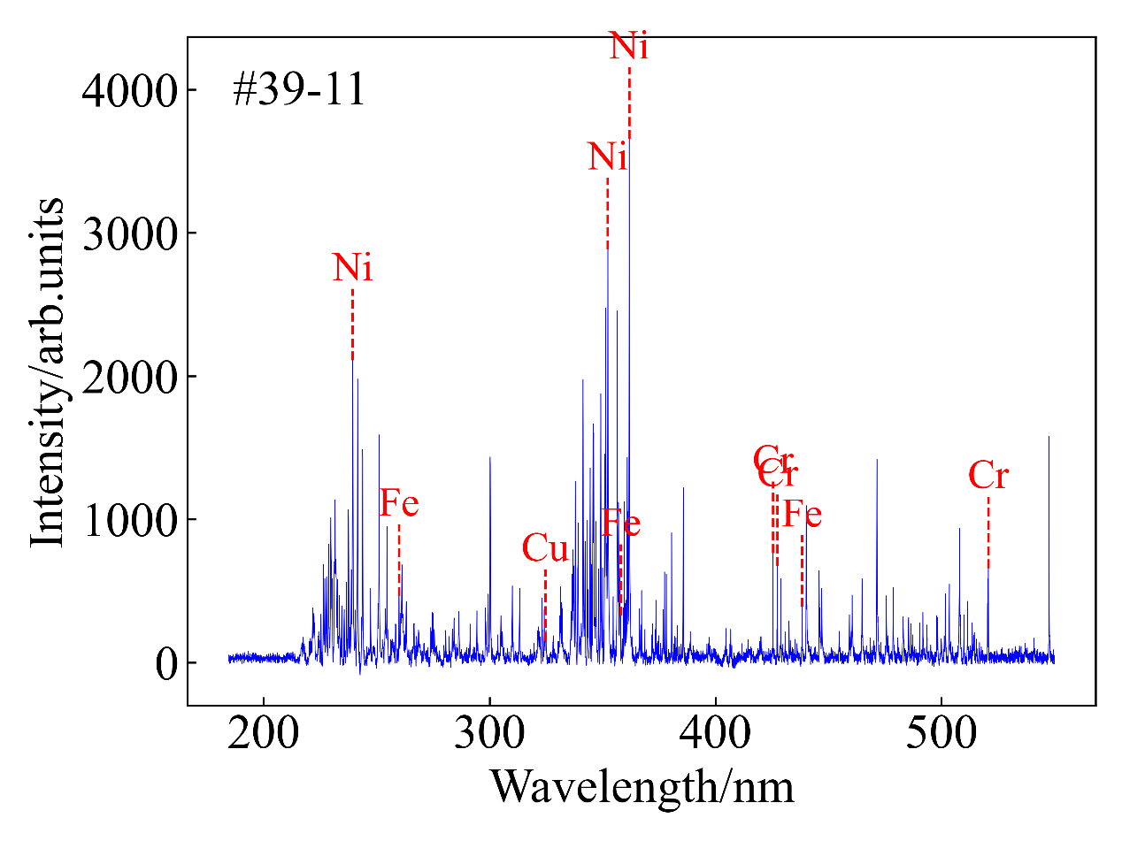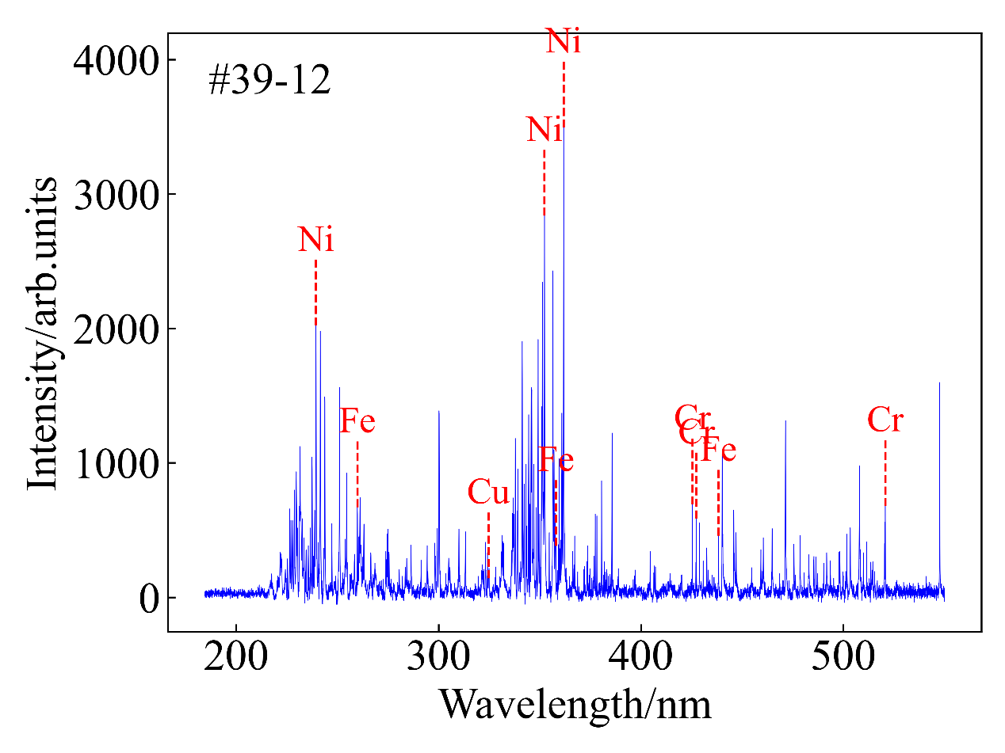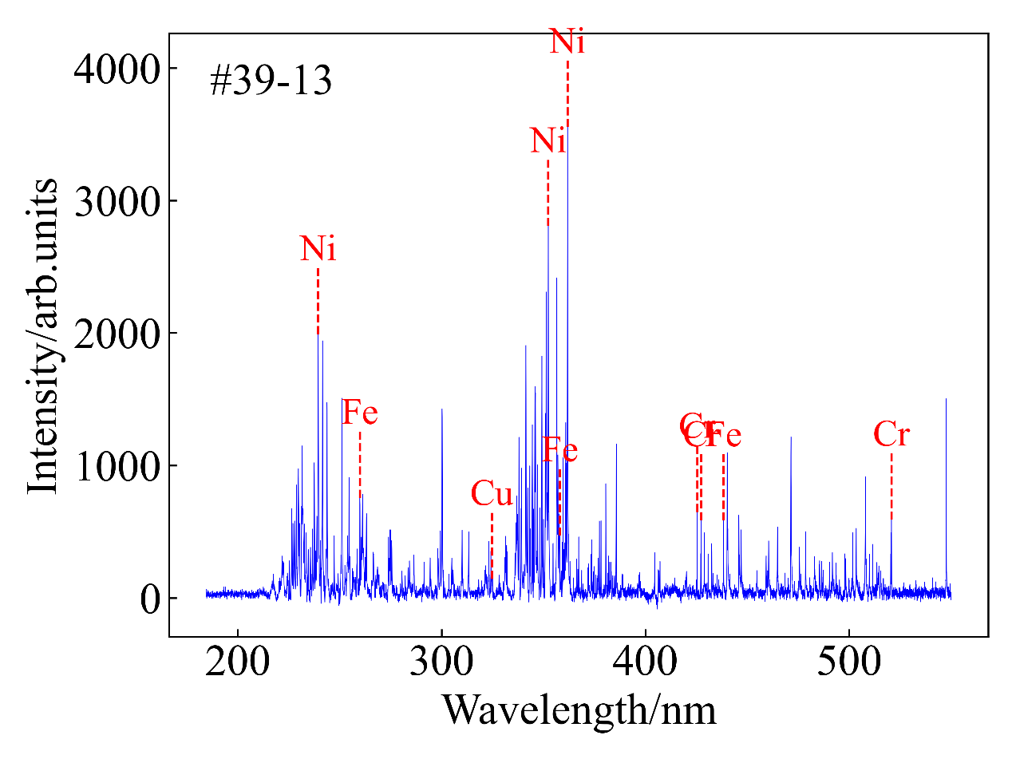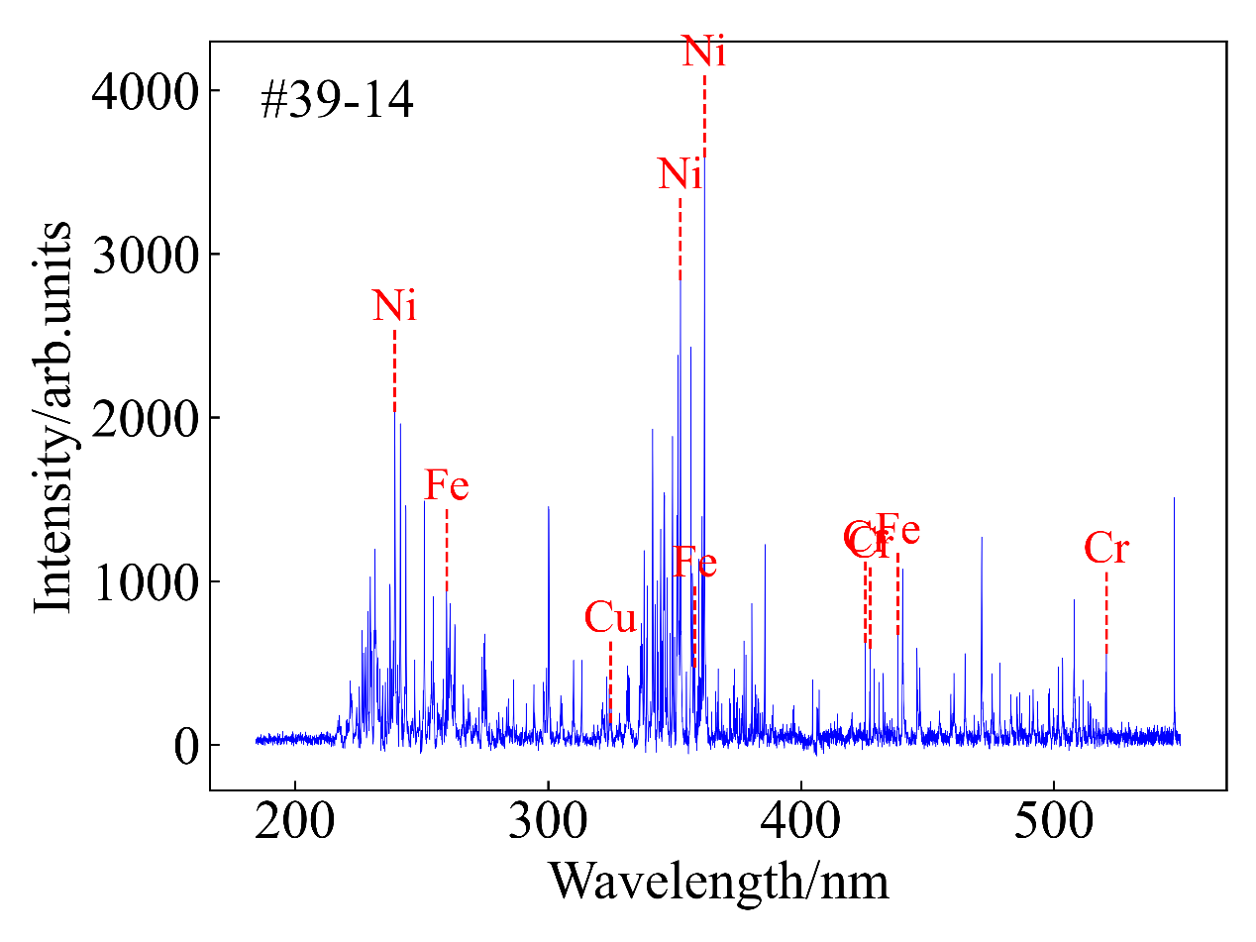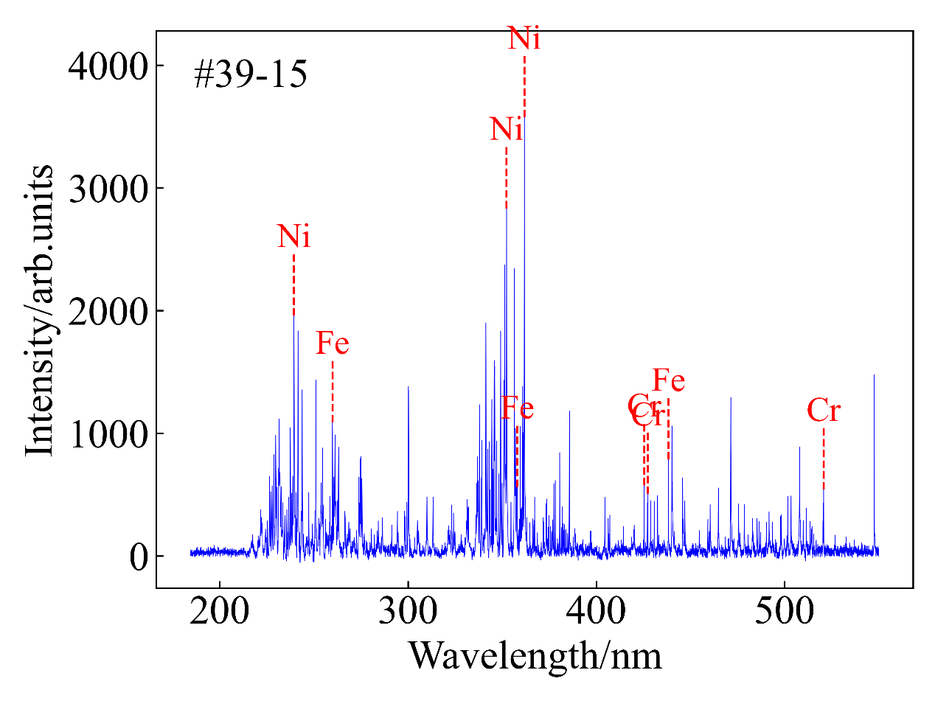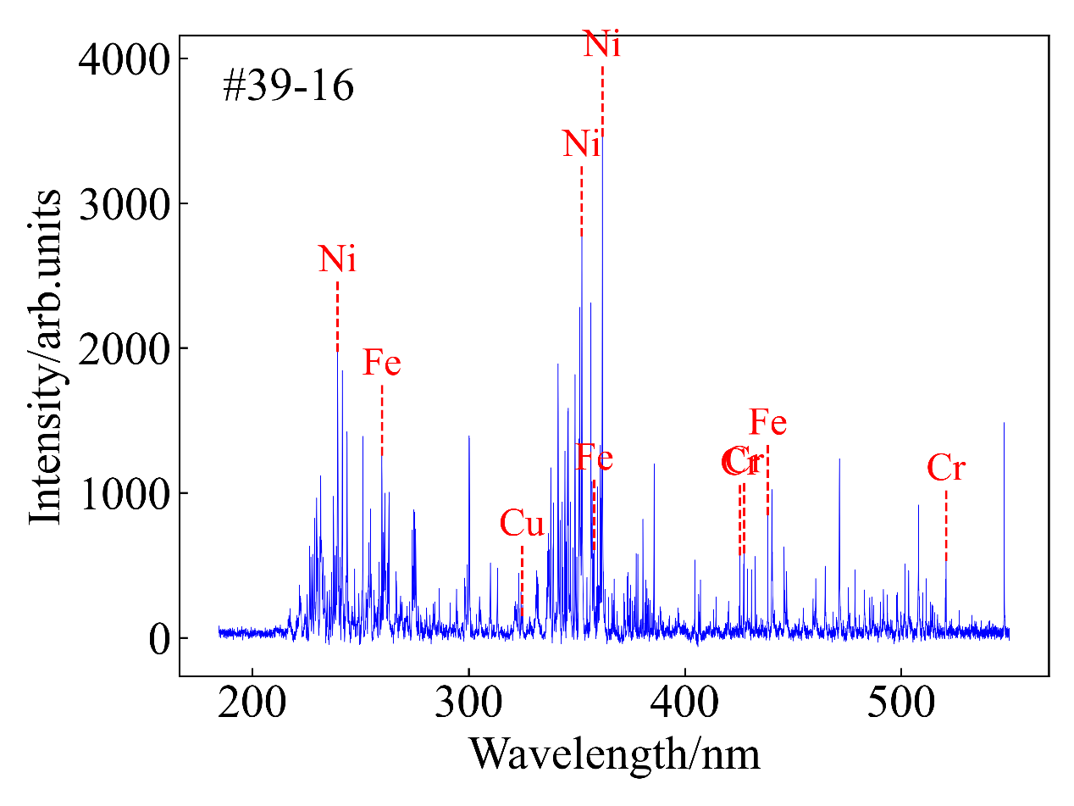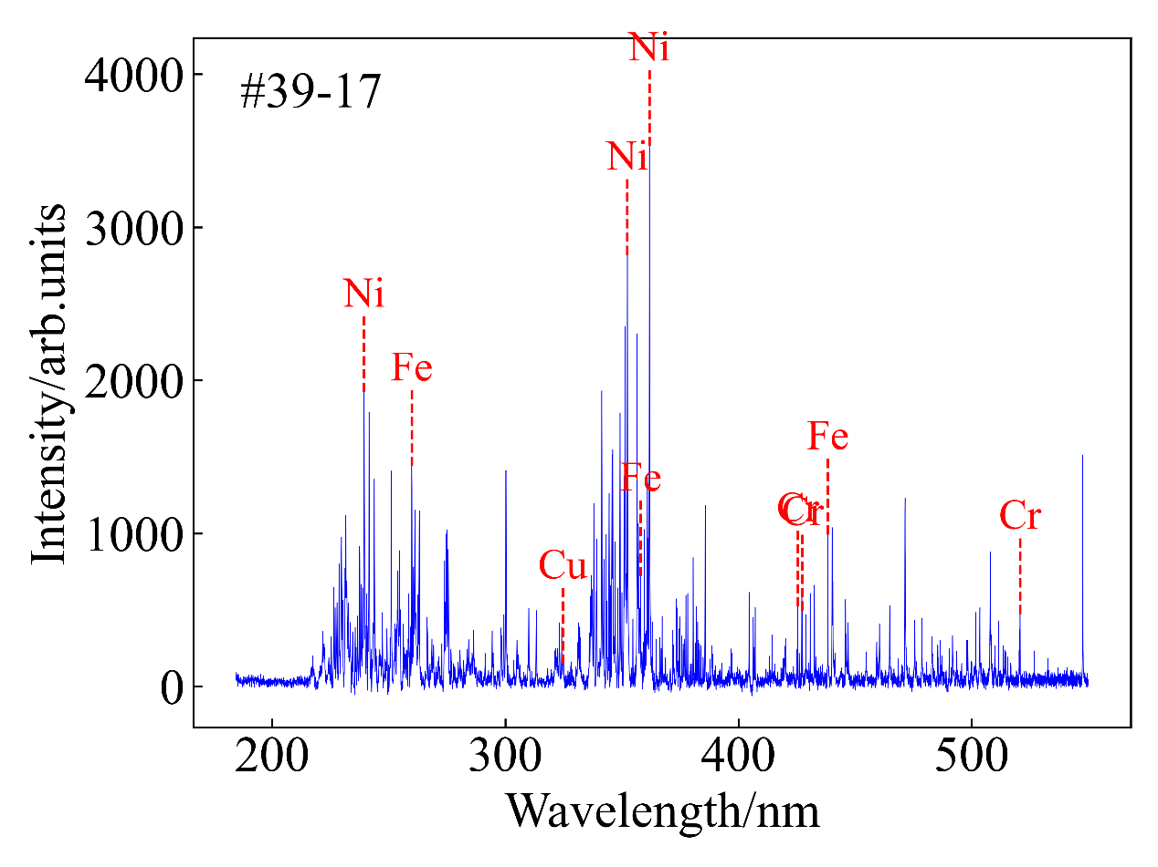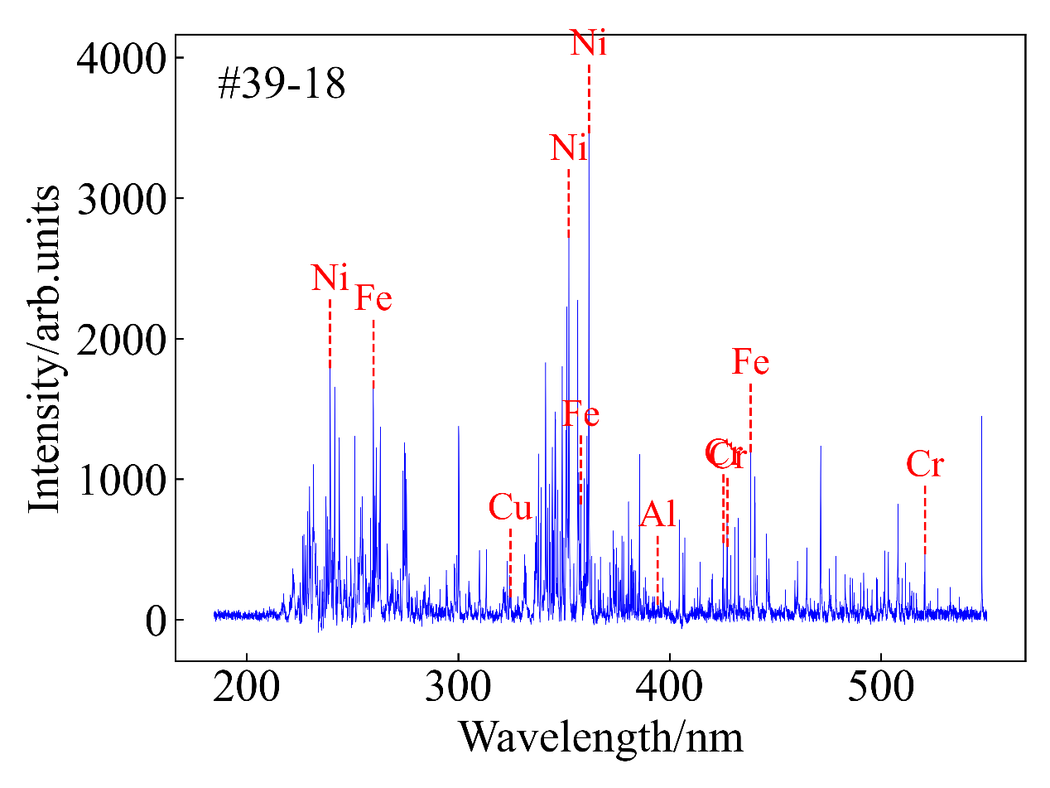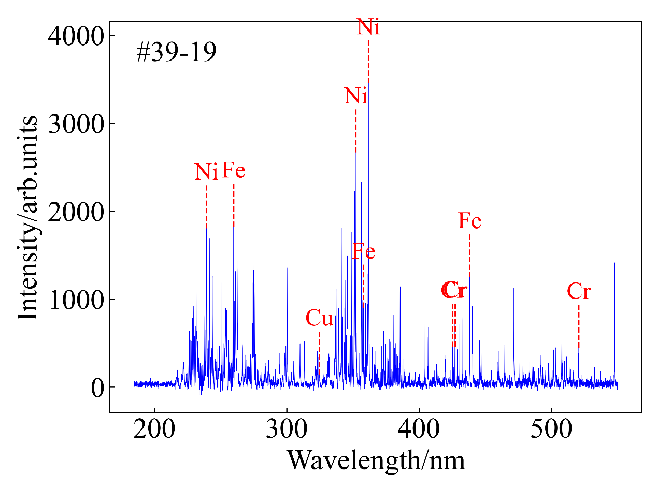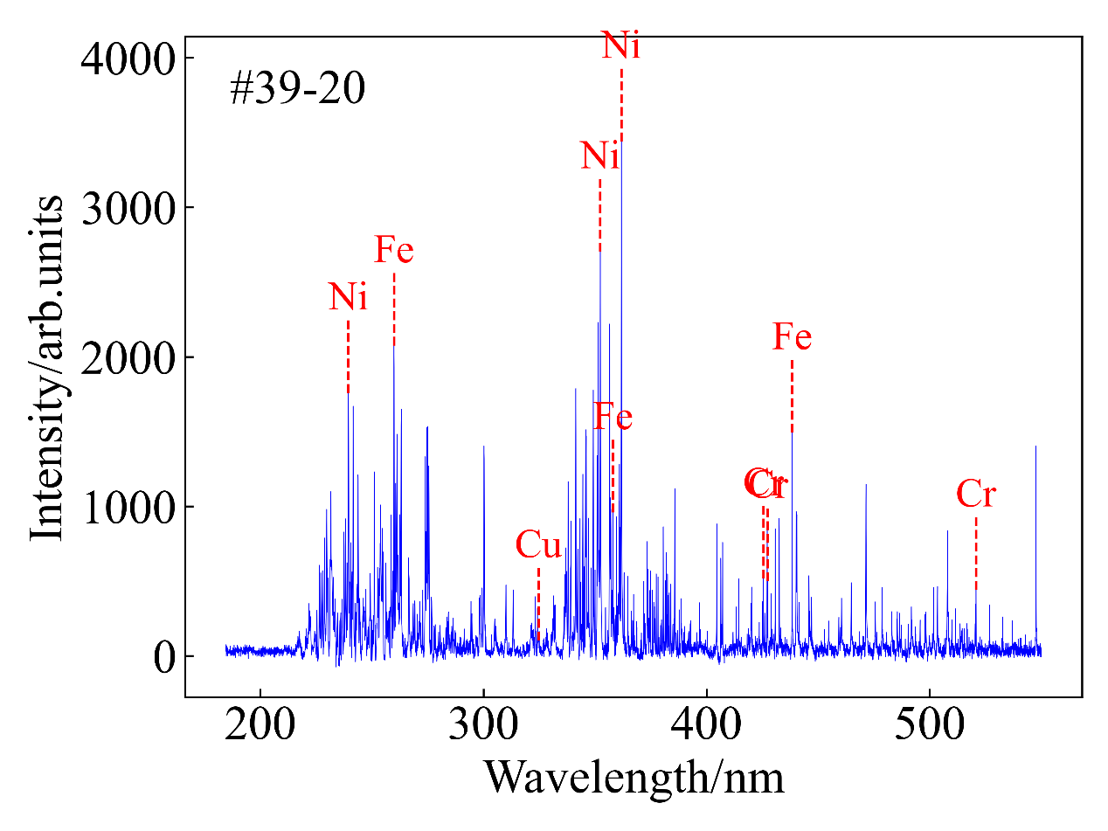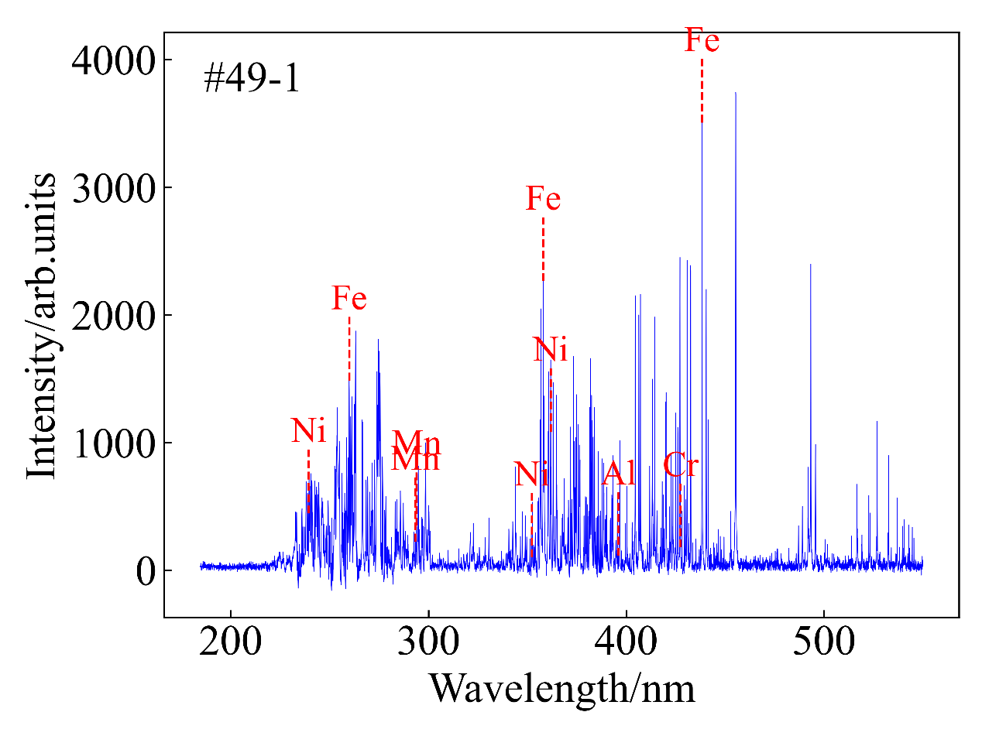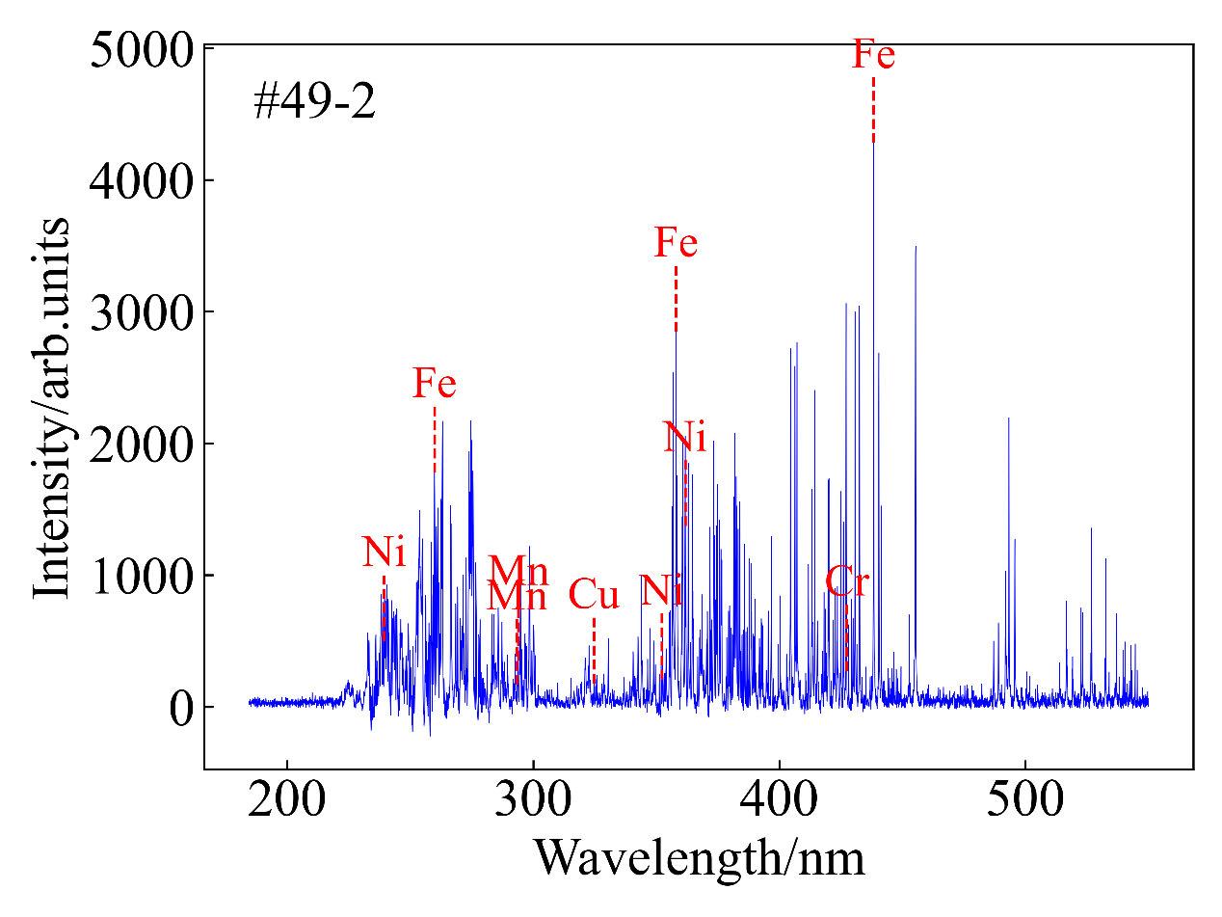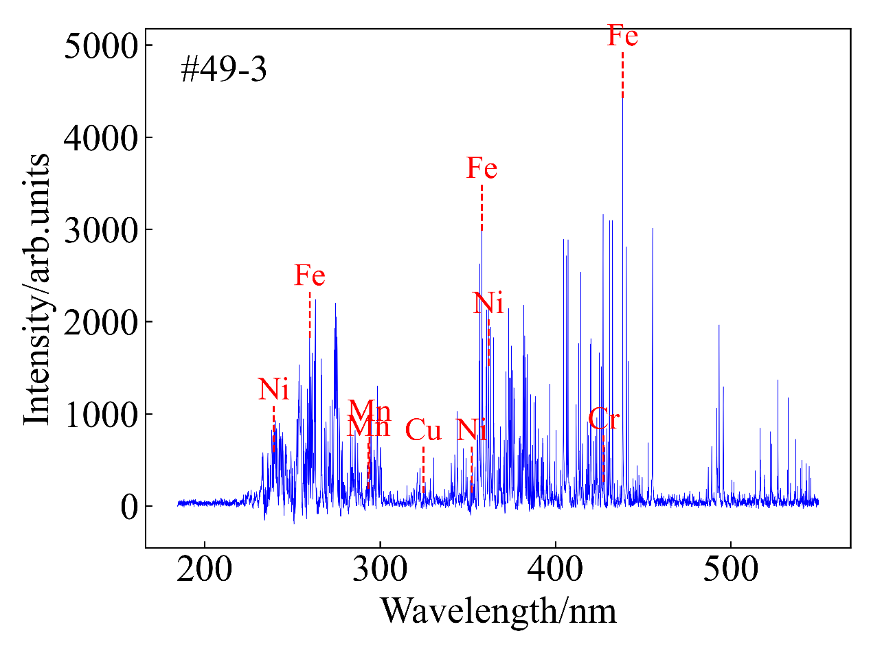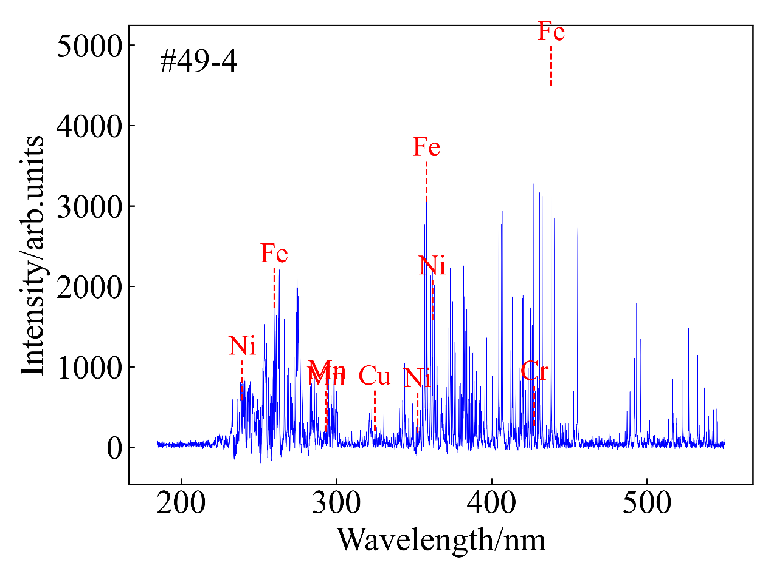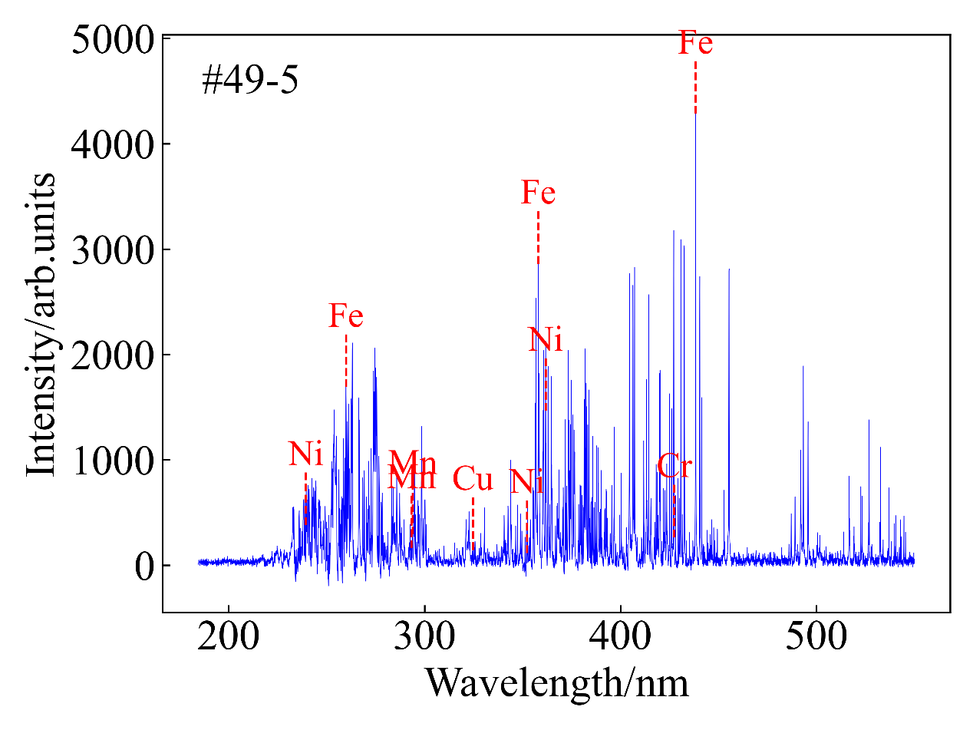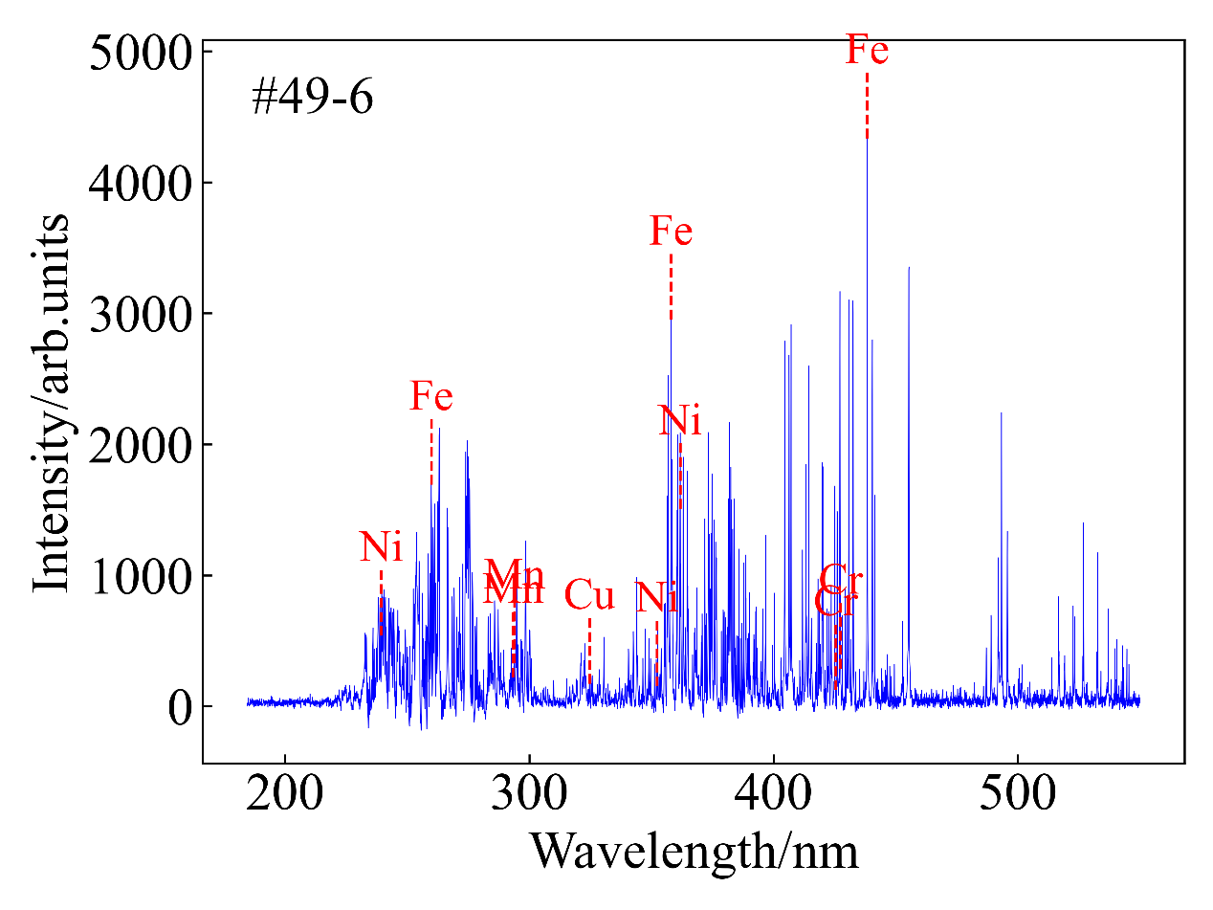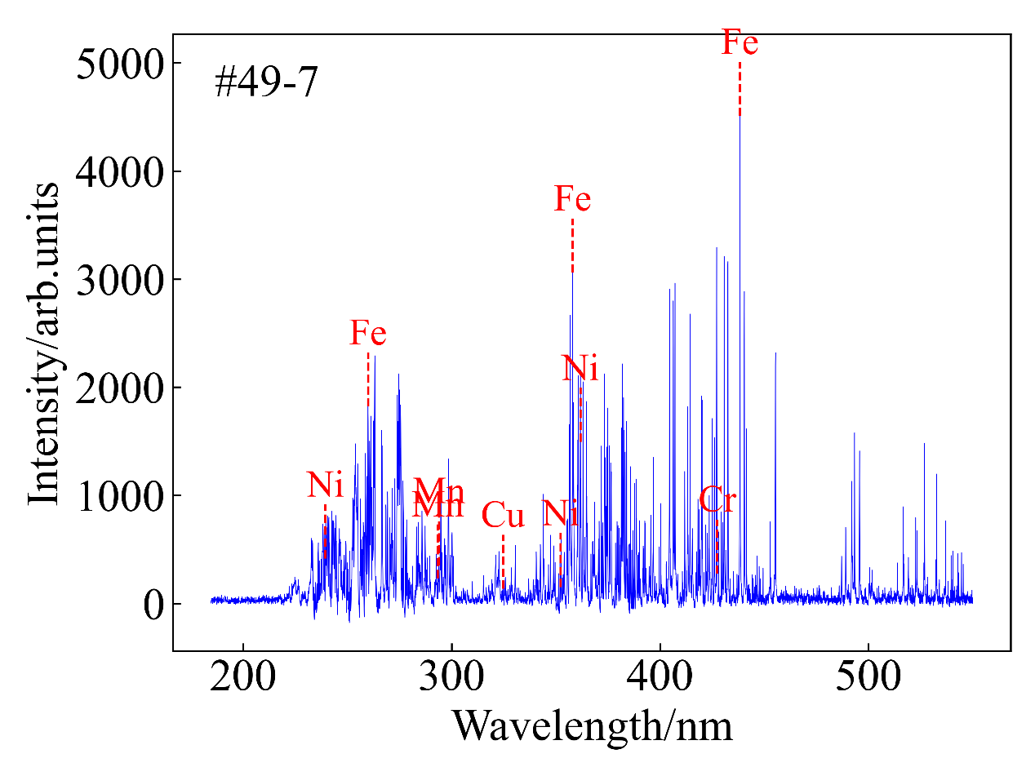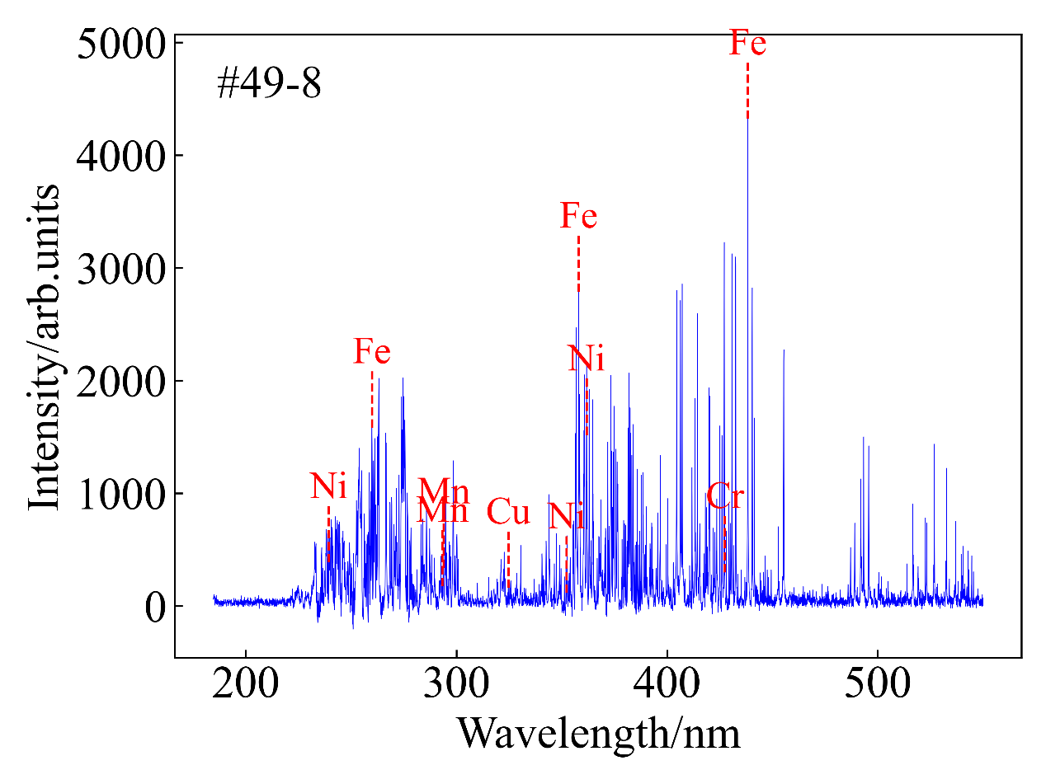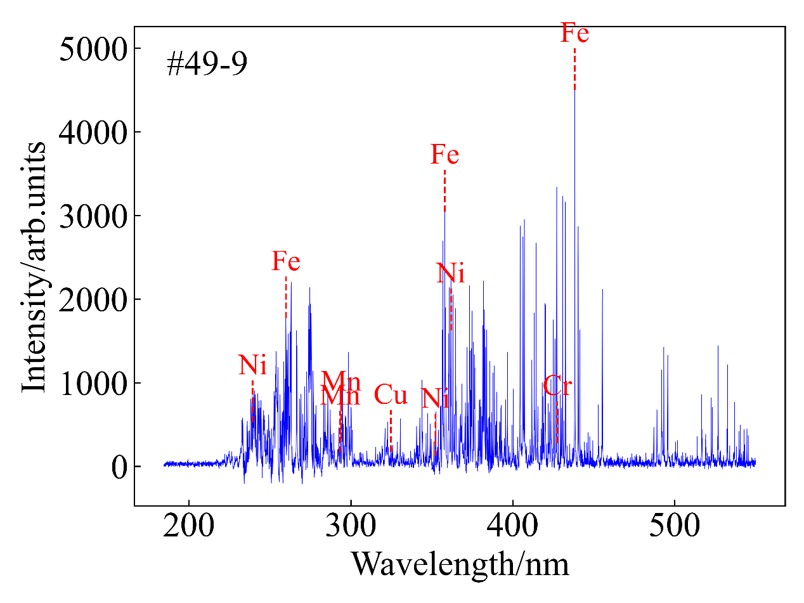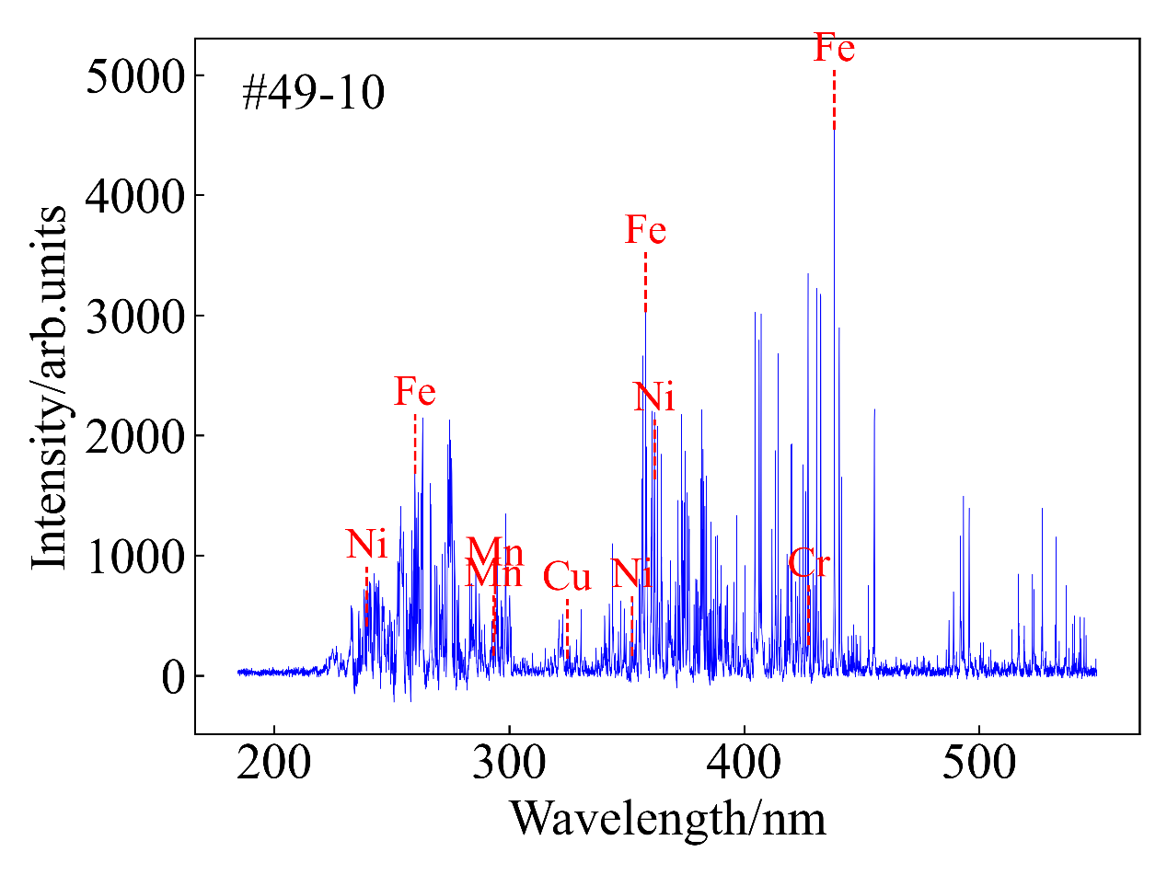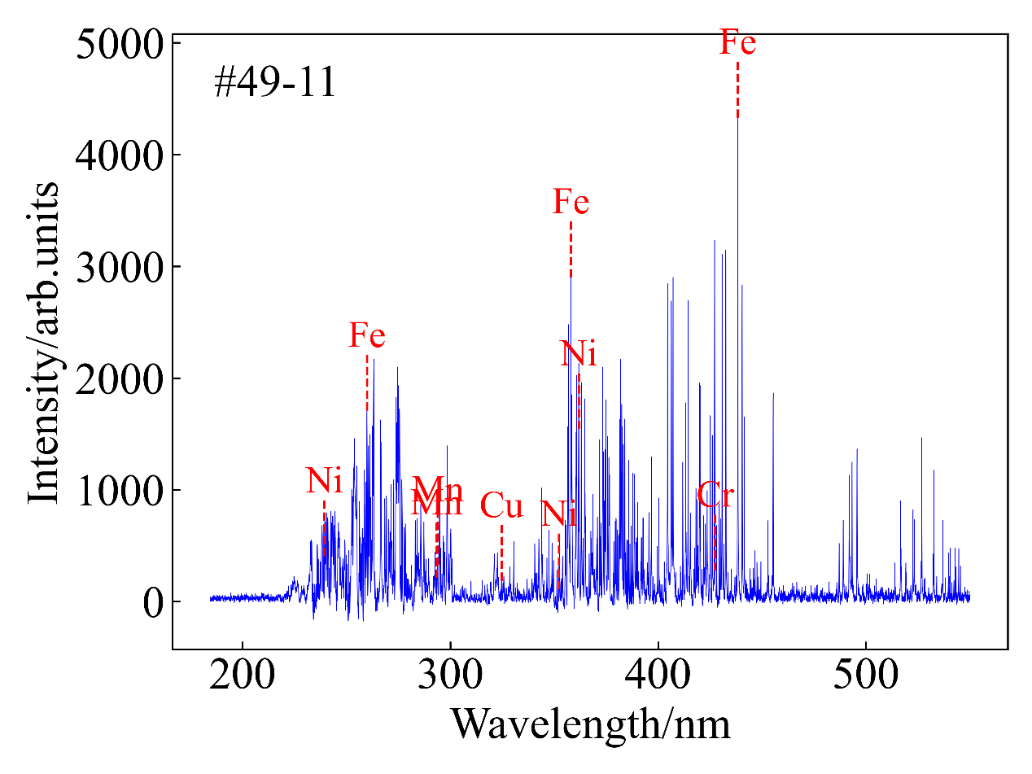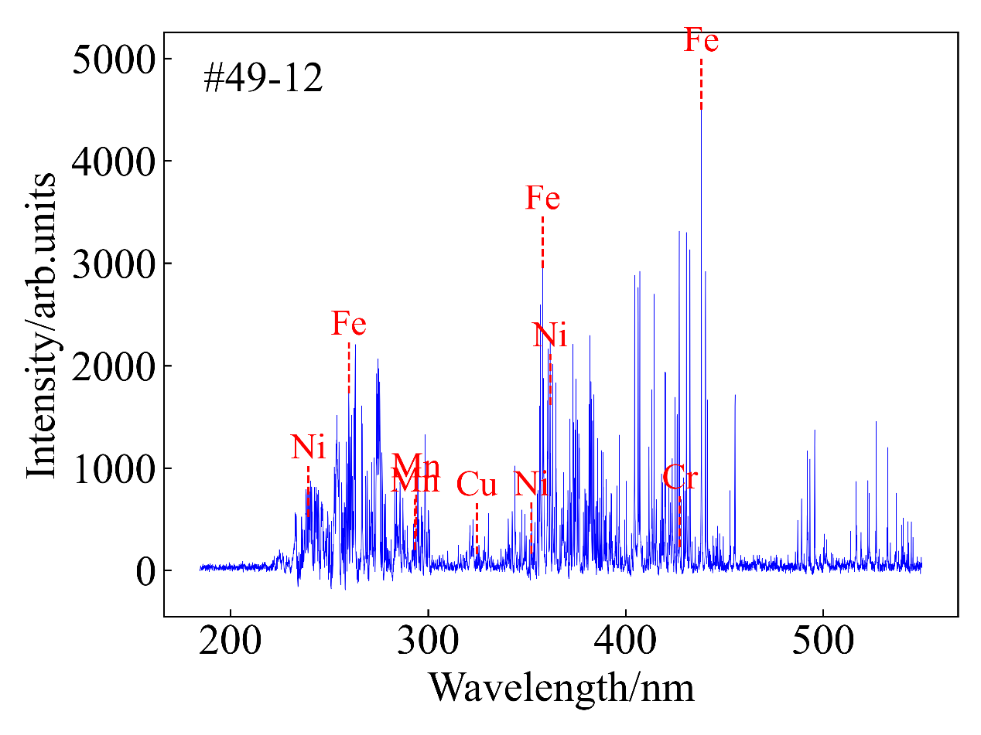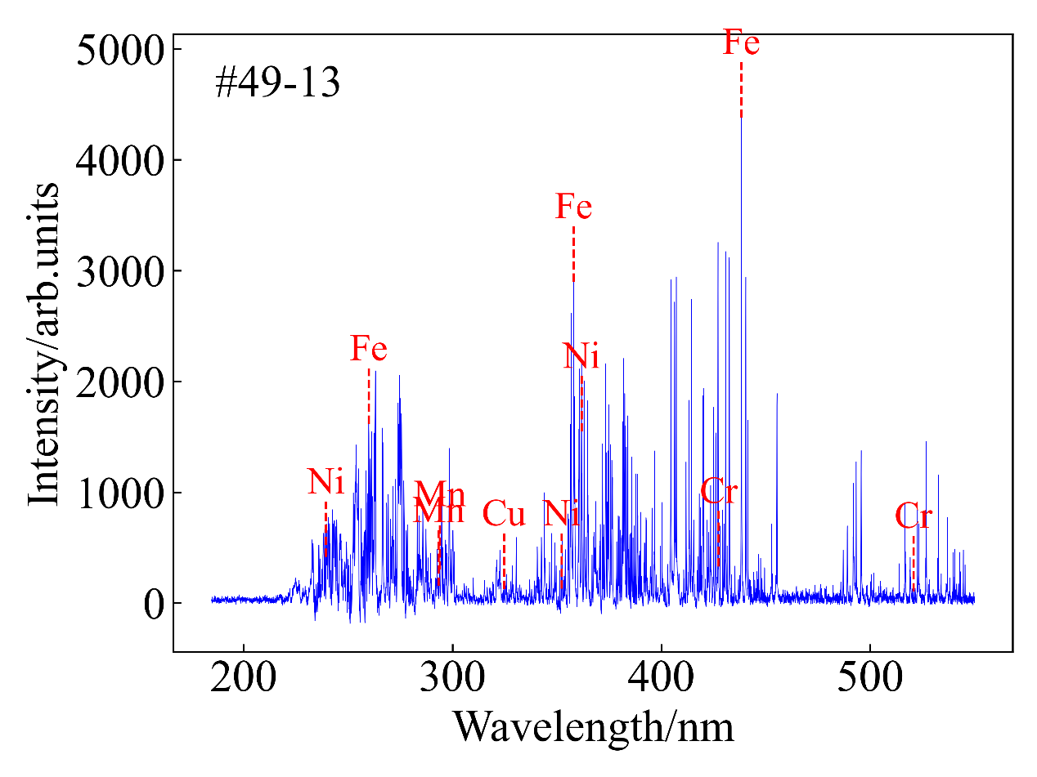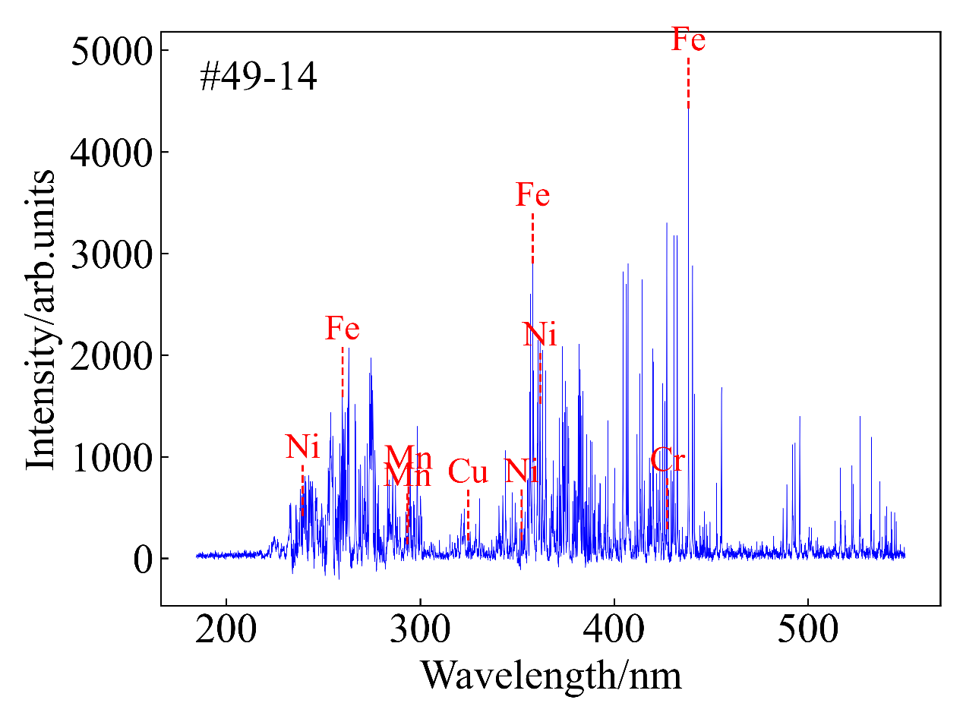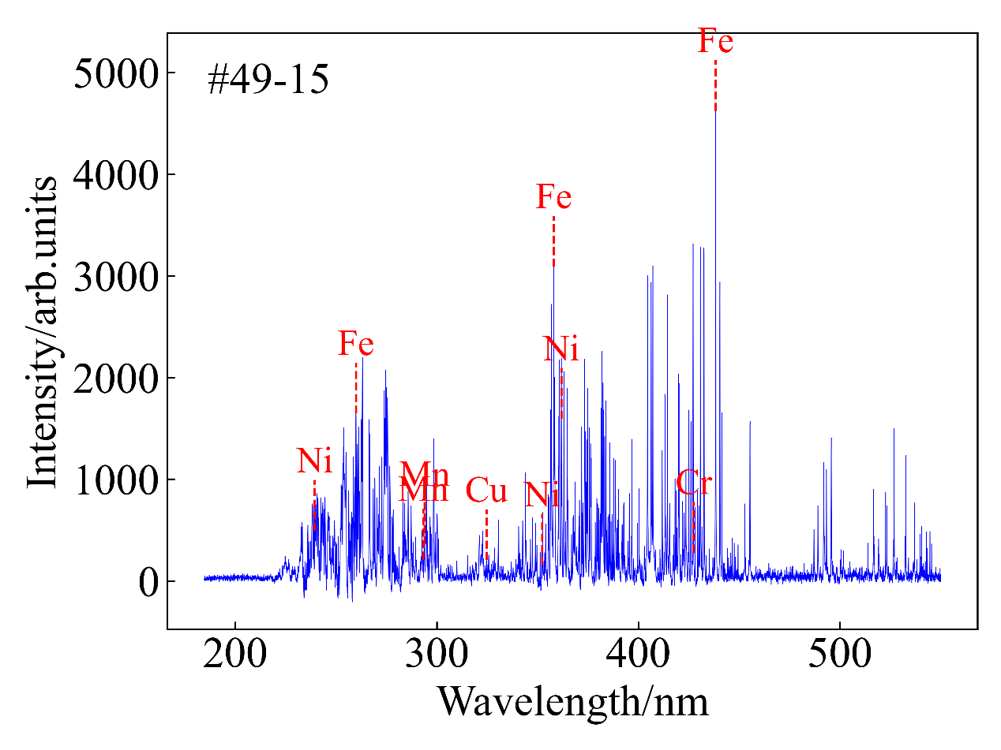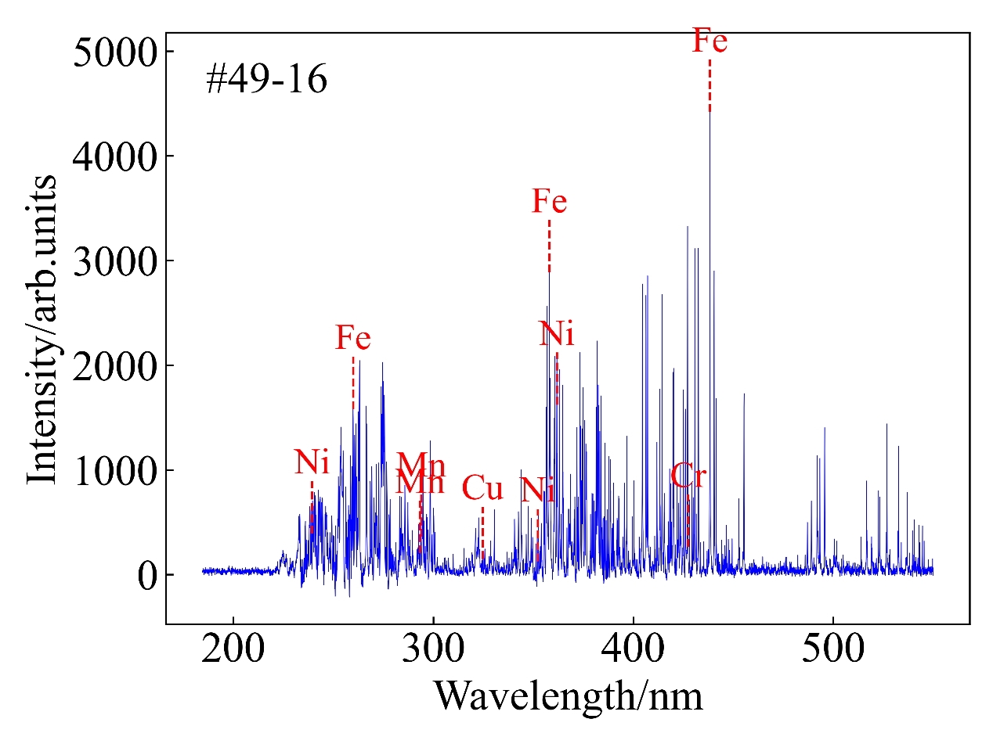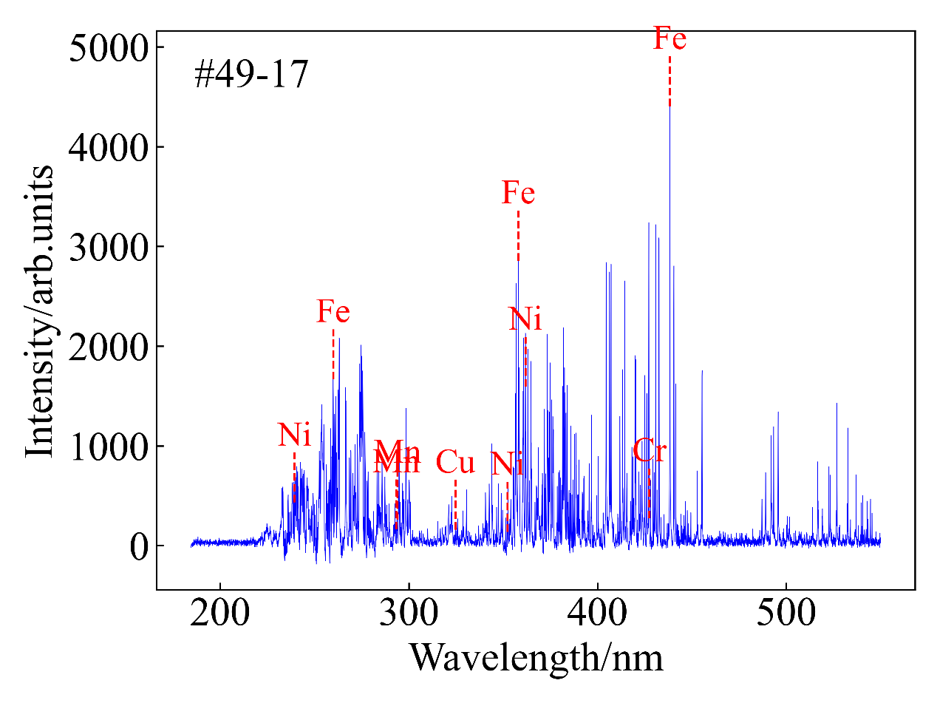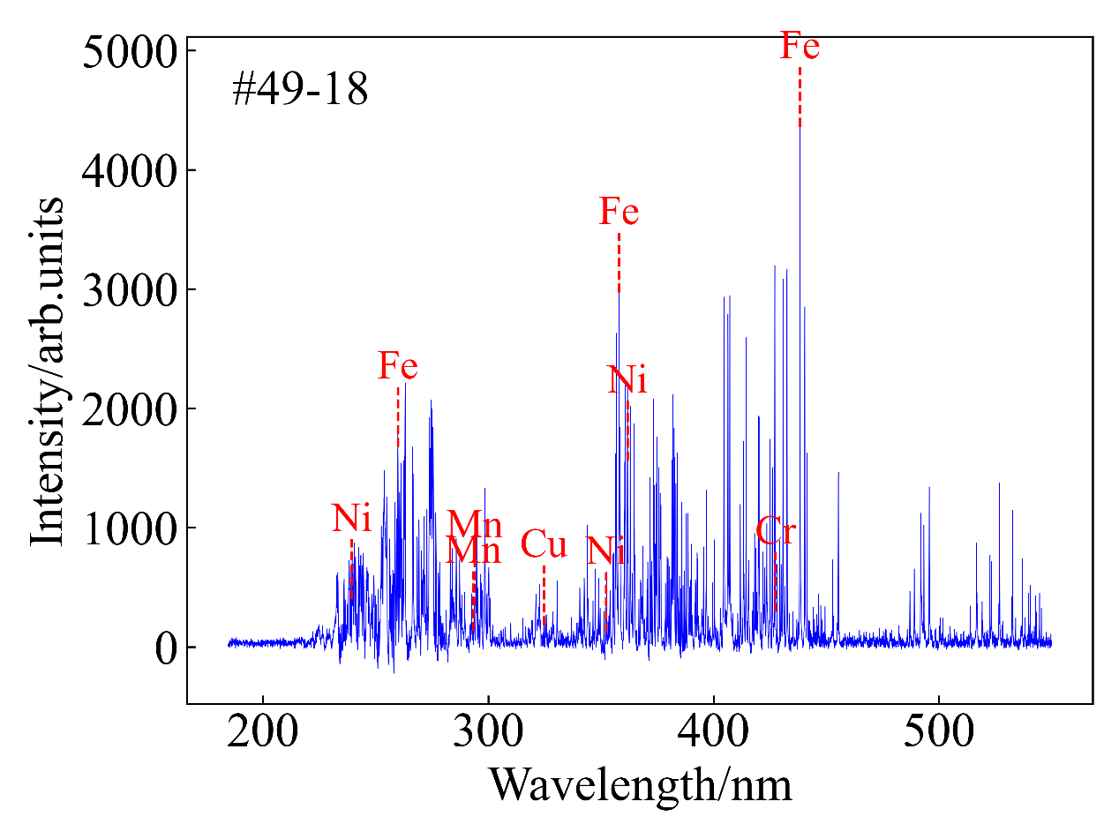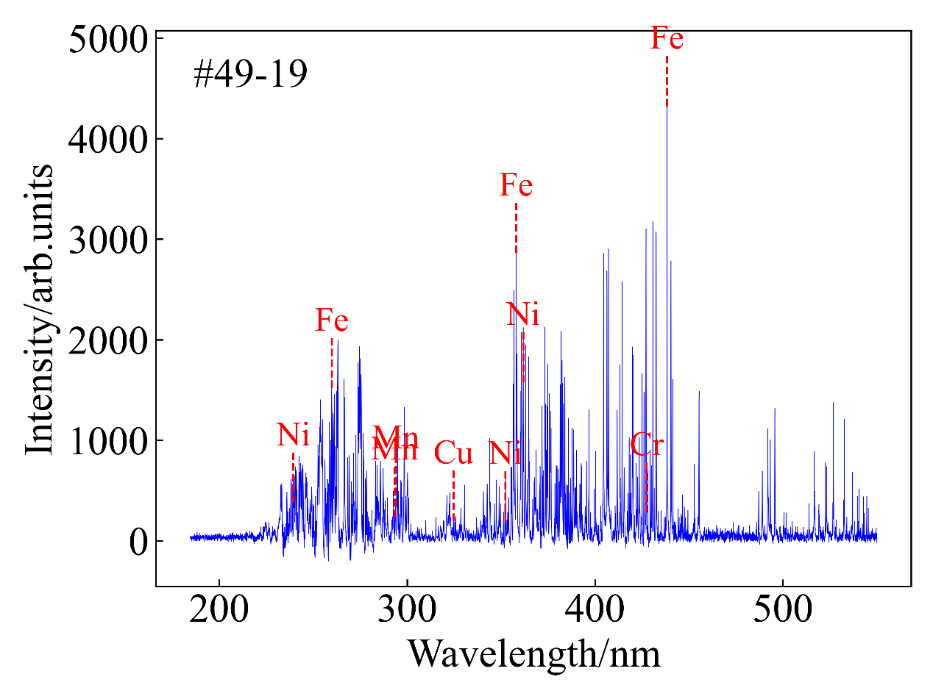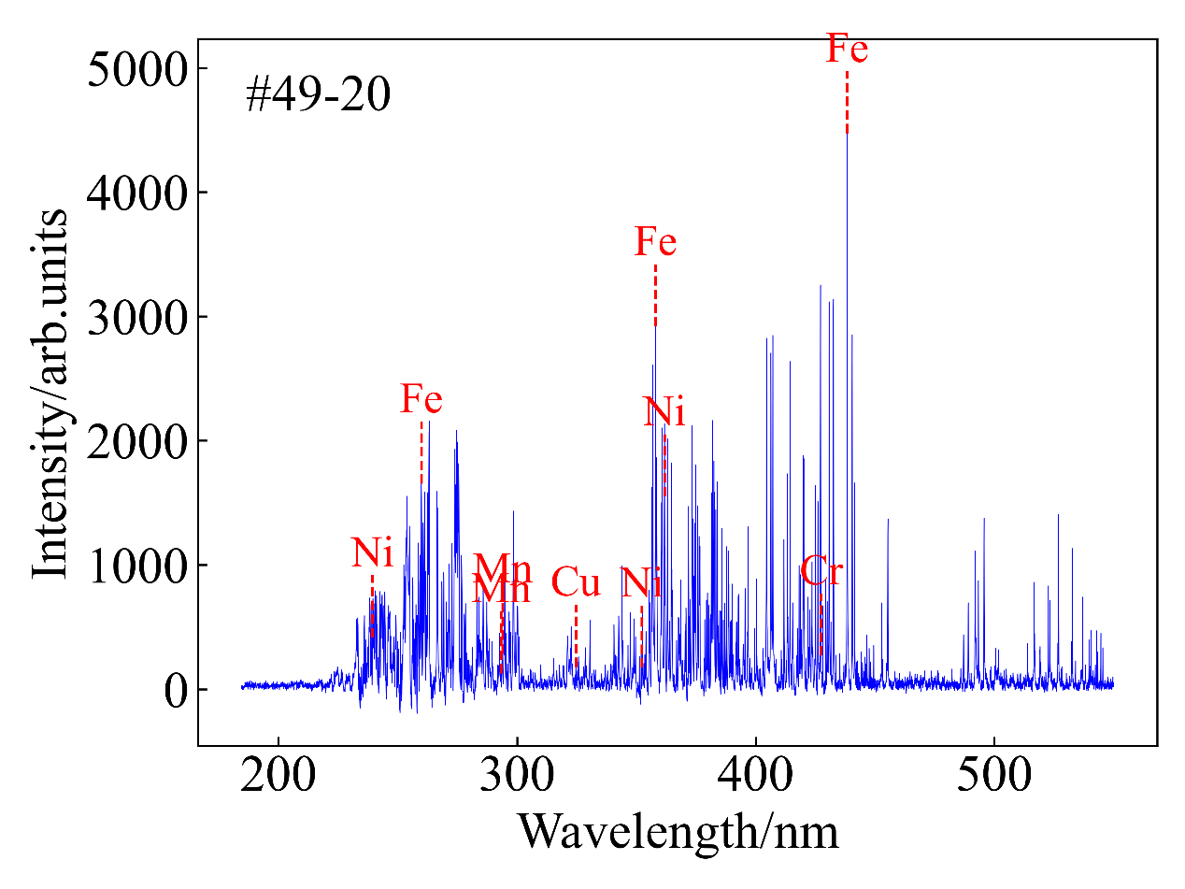

表 部分元素的XRF检测结果

Table The XRF Analysis Results of Some Elements unit: ppm

|  |  |  |  |  |  |  |  |  |  |
| --- | --- | --- | --- | --- | --- | --- | --- | --- | --- |
| Sample | Bal | Al | Si | Cr | Mn | Fe | Ni | Cu | Zn |
| #1 | 48500 | 12500 | 2700 | 430 | 15200 | 917100 | 0 | 0 | 0 |
| #2 | 56200 | 4800 | 2800 | 302 | 5100 | 927100 | 0 | 0 | 0 |
| #3 | 175500 | 3900 | 3900 | 447 | 4400 | 794400 | 0 | 211 | 0 |
| #4 | 61100 | 7700 | 3500 | 280 | 5100 | 917000 | 0 | 0 | 0 |
| #5 | 55200 | 4600 | 4500 | 742 | 5900 | 922100 | 322 | 178 | 0 |
| #6 | 0 | 6300 | 2300 | 814 | 13400 | 914600 | 0 | 0 | 0 |
| #7 | 50900 | 9300 | 3200 | 255 | 5000 | 908900 | 0 | 0 | 0 |
| #8 | 26800 | 5600 | 3100 | 318 | 6700 | 930800 | 0 | 0 | 0 |
| #9 | 76800 | 3300 | 2600 | 411 | 5700 | 906800 | 0 | 0 | 0 |
| #10 | 52500 | 6300 | 2400 | 355 | 5600 | 930400 | 0 | 0 | 0 |
| #11 | 51300 | 7800 | 2800 | 459 | 14000 | 920500 | 0 | 0 | 0 |
| #12 | 82100 | 5600 | 2100 | 493 | 5200 | 899900 | 0 | 0 | 0 |
| #13 | 50500 | 9400 | 4300 | 370 | 13500 | 906100 | 0 | 171 | 0 |
| #14 | 340300 | 6100 | 3900 | 234 | 3800 | 622200 | 0 | 194 | 0 |
| #15 | 54900 | 7800 | 3600 | 332 | 5900 | 920800 | 292 | 0 | 114 |
| #16 | 61100 | 5600 | 3300 | 456 | 6000 | 918900 | 0 | 0 | 0 |
| #17 | 95100 | 5000 | 2500 | 532 | 4800 | 885300 | 0 | 182 | 0 |
| #18 | 47300 | 4300 | 4000 | 530 | 14000 | 925900 | 0 | 427 | 0 |
| #19 | 64500 | 5000 | 4800 | 589 | 13900 | 905900 | 316 | 306 | 0 |
| #20 | 187200 | 14400 | 5700 | 531 | 4900 | 774500 | 0 | 0 | 0 |
| #21 | 78600 | 7900 | 2800 | 502 | 13300 | 893600 | 0 | 0 | 0 |
| #22 | 0 | 7100 | 4100 | 283 | 5600 | 919700 | 0 | 0 | 0 |
| #23 | 51200 | 5900 | 4700 | 822 | 11900 | 919500 | 617 | 953 | 0 |
| #24 | 63500 | 3900 | 4300 | 477 | 12700 | 913000 | 0 | 0 | 0 |
| #25 | 61900 | 6700 | 4000 | 358 | 13000 | 908100 | 0 | 0 | 0 |
| #26 | 71300 | 0 | 2000 | 252 | 4600 | 883700 | 0 | 160 | 0 |
| #27 | 66500 | 5600 | 2400 | 683 | 13000 | 887400 | 294 | 321 | 0 |
| #28 | 146600 | 12400 | 5700 | 1800 | 6400 | 821900 | 0 | 198 | 0 |
| #29 | 61600 | 2700 | 2500 | 456 | 5300 | 924100 | 0 | 0 | 0 |
| #30 | 189200 | 4100 | 933 | 343 | 5100 | 786400 | 0 | 201 | 0 |
| #31 | 163100 | 7800 | 3100 | 400 | 5500 | 816200 | 0 | 295 | 0 |
| #32 | 233500 | 10900 | 5400 | 405 | 4000 | 723000 | 0 | 155 | 0 |
| #33 | 44200 | 9700 | 4500 | 1500 | 10600 | 922400 | 0 | 1000 | 0 |
| #34 | 200900 | 8400 | 4900 | 319 | 5600 | 765100 | 0 | 224 | 0 |
| #35 | 192700 | 5000 | 1300 | 422 | 5500 | 770100 | 0 | 0 | 0 |
| #36 | 78000 | 6500 | 1500 | 489 | 5000 | 904300 | 0 | 168 | 0 |
| #37 | 166900 | 3500 | 590 | 0 | 4900 | 820800 | 0 | 0 | 90 |
| #38 | 169400 | 14400 | 5800 | 277 | 4800 | 800600 | 0 | 0 | 0 |
| #39 | 512000 | 0 | 4300 | 8100 | 982 | 201200 | 722900 | 0 | 313 |
| #40 | 0 | 2100 | 788 | 239 | 5300 | 496000 | 486900 | 0 | 0 |
| #41 | 0 | 11900 | 123000 | 22000 | 0 | 41900 | 406300 | 314700 | 0 |
| #42 | 0 | 0 | 937 | 201 | 2000 | 352600 | 561800 | 47900 | 2300 |
| #43 | 0 | 7900 | 4300 | 0 | 441 | 4700 | 3000 | 566700 | 371000 |
| #44 | 0 | 3900 | 4200 | 0 | 337 | 4000 | 3800 | 553600 | 370500 |
| #45 | 0 | 119000 | 1800 | 0 | 11600 | 28800 | 1700 | 832000 | 1800 |
| #46 | 0 | 0 | 1400 | 0 | 0 | 381 | 0 | 990000 | 1100 |
| #47 | 0 | 9000 | 2200 | 148 | 2000 | 9600 | 5100 | 582800 | 350100 |
| #48 | 0 | 15900 | 2100 | 0 | 147 | 6200 | 278 | 970100 | 0 |
| #49 | 478700 | 8900 | 9800 | 784 | 2300 | 126700 | 0 | 0 | 0 |
| #50 | 502100 | 5500 | 8700 | 997 | 2700 | 96600 | 0 | 0 | 120 |
| #51 | 484600 | 3100 | 5500 | 830 | 3100 | 203800 | 3100 | 5500 | 0 |
| #52 | 447400 | 6200 | 7900 | 697 | 4400 | 246500 | 0 | 0 | 0 |